Technical Report

2017

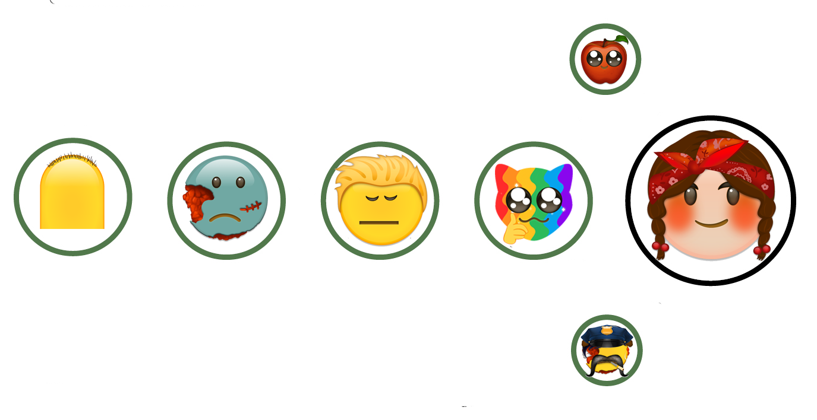

Digital Wellbeing

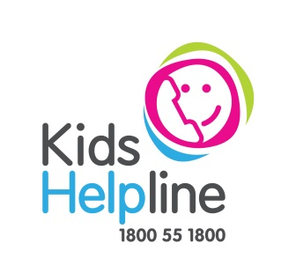*Youth Engagement Consultation Project* 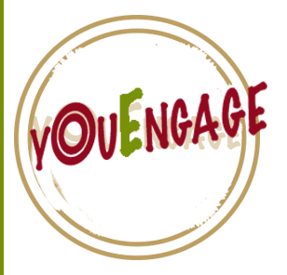

Karleen Gwinner

Peter Melrose

Amanda Moffat

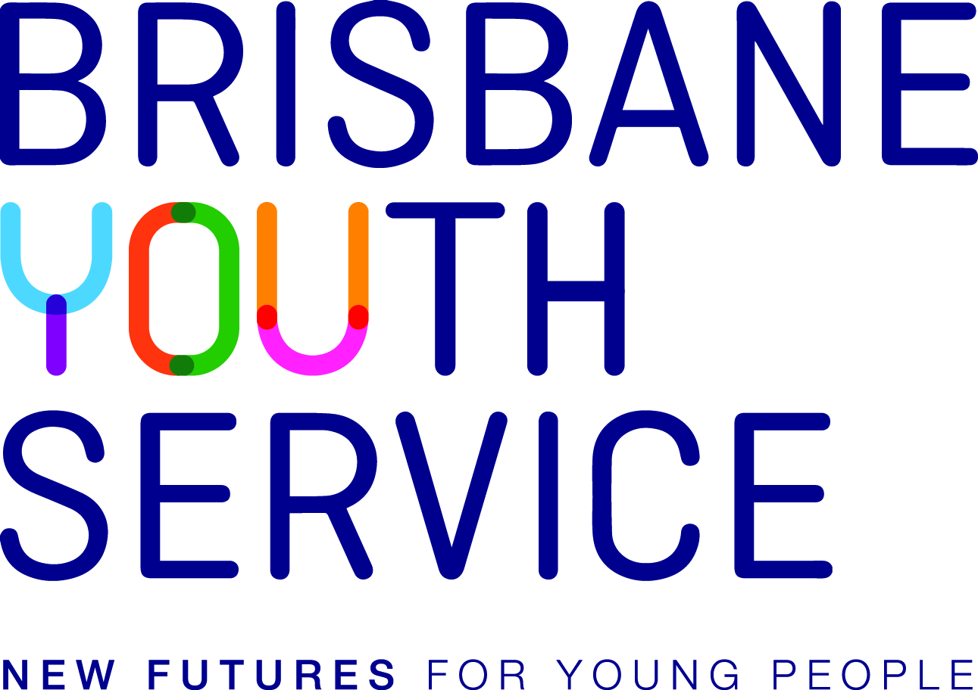

# Overview

The *Digital Wellbeing* *Youth Engagement Consultation Project* was conducted on behalf of Kidshelpline and Brisbane Youth Service. The consultation involved a multi-pronged approach to provide first-hand insights of young people’s expectations, experiences and needs for innovative technology solutions to promote youth wellbeing and strengthen the effectiveness of worker-young person support processes. This consultation was funded by the Optus Future Maker fund.

The Consultation team worked in a collaborative approach with the stakeholders to refine and deliver the project plan with mutually agreed key questions, methodologies and outcomes.

## Consultation team

The consultation team was led by Dr Karleen Gwinner. Peter Melrose oversaw the survey and quantitative components. Dr Amanda Moffat facilitated the digital arts-based workshops and provided insight to co-design and engagement practices. We would also like to recognise Kelly Anderson for her valuable contribution to the survey and preparation of the data, and Dylan Hegerty for his assistance during recruitment and facilitation of the workshops.

## Acknowledgements

We would like to distinguish the collaborative contribution of Rhianon Vichta, Research and Evaluation Coordinator at the Brisbane Youth Service, and Brian Collyer, Senior Researcher at **yourtown**. Their direction, input and advice has been invaluable for meeting the goals of the project and to ensure young people’s perspectives were contextualised throughout the project.

The authors are grateful to the young people who provided their insights, and made this research possible.

The funds provided through the Optus Future Maker funding for innovative technological solutions for vulnerable young people have made the consultation possible.

Suggested citation

Gwinner K., Melrose P. and Moffat A. (2017). *Digital Wellbeing, Youth Engagement Consultation Project: Technical Report*. Brisbane, Australia. Kidshelpline, and Brisbane Youth Service. [www.](http://www.australianchildwellbeing.com.au)

# Contents

Overview 2

Consultation team 2

Acknowledgements 2

Contents 3

List of Tables 3

List of Charts 3

List of Figures 3

Executive Summary 5

Key Learnings 6

Wellbeing 7

Engagement, relationships and connection 7

Digital technologies 7

Co-Design 8

Introduction 9

Consultation Approach 11

Challenges 11

Ethical oversight 12

Risks and benefits 12

Recruitment and consent 13

Questions 13

Interpretation and analysis of the data 14

Alignment with Stakeholder Objectives 14

Brisbane Youth Service 15

**yourtown** 16

Framework, key topic areas 17

1. Wellbeing 18

2. Engagement, relationships and connections 19

3. Digital technologies 20

4.Co-design 21

Methods 23

Workshops 23

Focus Groups 26

Survey 28

Profile/Casestudy 30

Kasey 30

Luke 31

Dana 32

RESULTS 33

Key topic areas 33

Data collection and analysis map 33

Wellbeing 36

Engagement, relationships and connections

Digital technologies 55

Co-design 67

Conclusion and Learnings 73

Onwards 77

References 79

Appendices 83

Appendix 1 83

Appendix 2 88

## List of Tables

Table 1. Data collection and analysis map 37

## List of Charts

Chart 1. Workshop gender demographic 26

Chart 2. Workshop cultural demographic 27

Chart 3. Q20 I have what I want in life 38

Chart 4. Q38 being treated with respect 44

Chart 5. Q48 The last time I spoke to someone like a counsellor/youthworker (or other person who helped me), it was... 44

Chart 6. Q53 If I was going to use a really good digital app or website I would like it to have… 48

Chart 7. Q23 For help with my problem/s I went to (please tell us who and or where you went for help) 50

Chart 8. Q8 When I use the internet, I 57

Chart 9. Q25 I have used these to help deal with problems 60

Chart 10. Q26 If you could use an app or website to help you deal with problems, what would the thing you most likely use look like? 61

Chart 11. Q15 On a scale of 1-5 (5 being always) I mostly use these apps for? 63

Chart 12. Q46 Think about how you want your privacy and information managed online by the counsellor/youthworker (or other person helping you). Do you think it is important to… 65

## List of Figures

Figure 1. A personal emoji from workshop task 4 39

Figure 2 - Drawing and writing activity workshop 1 T2 40

Figure 3 Q4 Word cloud from the question ’ Can you please finish the sentence "wellbeing is..."’ 41

Figure 4. A personal emoji from focus groups task 4 43

Figure 5. Drawing from focus group illustrating requisite for contact from workers 45

Figure 6 Drawing illustrating support for everyday wellbeing goals 45

Figure 7. Drawing from workshop 51

Figure 8. Focus group and workshop images 51

Figure 9. Using emojis map design for an app workshop T 9 53

Figure 10. Q8 word cloud “When I use the internet, I…” 58

Figure 11. Q10 word cloud When I play games using digital technologies, my favourite games is 59

Figure 12. Q53 If I was going to use a really good digital wellbeing app or website I would like it to have... 62

Figure 13. Q14 Can you name a couple of apps that you use? 63

Figure 14. Image from workshop task 7 66

Figure 15. Image from focus group task 9 66

Figure 16. Illustration from Focus Group task 9 68

Figure 17. Personal emojis from workshops and focus groups 69

# Executive Summary

Early in 2017, as recipients of Optus Future Maker funding for innovative technological solutions for vulnerable young people,Brisbane Youth Service (BYS) and **yourtown** sought to undertake a youth engagement research project to examine innovative approaches to using technology to promote youth wellbeing and strengthen the effectiveness of worker-young person support processes.

**yourtown** is a service that delivers services to tackle issues affecting the lives of children and young people. They do this through a range of services including counselling, helplines, crisis care, education and training, employment, parenting help, mentoring, social development and life skills. The youth engagement project was specifically attentive to **yourtown**’s Kids Helpline service. <https://www.yourtown.com.au/>

With a vision of **new futures for young people**, Brisbane Youth Service assists young people and young families to find and maintain safe housing, address physical and mental health issues, establish successful relationships and support networks and engage in education and employment so that they can thrive in the community. <http://brisyouth.org/>

The Optus Future Makers grant supported a partnership between Brisbane Youth Service, steered by Rhianon Vichta, and Kids Helpline, steered by Brian Collyer, to foster digital innovation and bring to life each stakeholder’s bold ideas to change the social landscape for young people. The Consultation team were recruited through an expression of interest with a clear remit to undertake a youth engagement research project within an immediate and short timeframe. Two crucial questions guided the usefulness of learnings for each stakeholder:

* What are the implications of young people’s perspectives of wellbeing for service provider’s understanding of wellbeing services?
* How can digital technologies be used in ways that support the effectiveness of worker-young person support processes and match young people’s priorities for wellbeing?

An emergent collaborative approach was devised with the aim to

* Develop a project plan with mutually agreed questions, approaches and methodologies.
* Employ a use mix of methods (e.g. focus groups, workshops and survey) to engage young people in meaningful conversation about their relationship with different digital technologies.
* Provide pragmatic learning about young people’s perceptions of what is important to their wellbeing and how apps and websites can promote wellbeing and strengthen relationships between young people and their workers/counsellors.

This report summarises the learnings from the *Digital Wellbeing* *Youth Engagement Consultation Project* (YouEngage). YouEngage used a mixed method approach to maximise participation and the authentic voice of young people in a very short timeframe. Specifically, a combination of an online survey, digital-arts based workshops and focus groups were used to explore the research questions. Data collection was conducted from 6th of March and concluded on the 19th of April 2017. In all, 404 young people who were actual or potential clients of BYS and Kids Helpline contributed their views and insights of wellbeing, digital technologies and service engagement to the consultation. Four key topic areas formed a framework for the collection of both quantitative and qualitative data. The results described in this report are presented under each key topic area,

1. Wellbeing,
2. Engagement, relationships and connections,
3. Digital technologies, and
4. Co-design.

## Key Learnings

The key learnings of the YouEngage consultation are summarised here in relation to the key topic areas. Each of the learnings highlight the multi-faceted picture of young people’s wellbeing, service delivery and digital technologies. So too, they provide a foundation for the stakeholders to further streamline methods to promote wellbeing and strengthen relationships between young people and their workers and /or counsellors.

### Wellbeing

* Young people’s wellbeing is multi-faceted and deeply in tune to beliefs of wellbeing prevailing as a person’s core meaning and value as a human being.
* Young people’s perception of wellbeing was highlighted as, a state, a right, an attitude and self-determined.
* Two components most identified by young people as what wellbeing is include, firstly, *health and being healthy*, closely followed by, *being happy and happiness*.
* Young people’s understanding and enactment of wellbeing were perceived to transpire in ways that can be contradictory and problematic for service provider’s understanding of wellbeing services.
* Being treated fairly and with respect was rated highly in connection to young people’s wellbeing, but some young people expressed that this does do not always occur when seeking support for their needs.

### Engagement, relationships and connection

* Of uppermost importance for young people was the need for services to respect and listen to where young people are at.
* Young people need and want personal contact and practical support to help them achieve their wellbeing goals.
* Cost free and stigma free services are highly important for young people to feel able to reach out and gain help.
* Being transient or homeless directly impacts young people’s capacity to access resources for their right to being well.
* Young people want to be in control of their connections and relationships to support their wellbeing through digital technologies.
* Trust is an important feature for engagement with services to support wellbeing. valued and sought after by young people.

### Digital technologies

* Smartphones were the defualt device to access connection to the internet.
* Participants use apps to find quick response for their wellbeing, while they would expect to be referred to websites for additional or more detailed information. They seek interactive platforms on both websites and apps, with apps being most used for games and general resources.
* Young people are using digital technologies in self-management and problem-solving approaches but they also want to engage with workers and services using digital technologies in ways that meaningfully support them to ‘talk through’ their everyday experiences.
* Young people want to use apps for peer support. They want access to tools that enable or enhance connection with friends, provide easy access to information and offer interactive learning opportunities.
* Young people have different expectation and requirements for privacy across digital platforms and usage.

### Co-Design

* Co-design processes with young people will need to be organised with relevance to the design of connections, rapport, self-determination, privacy, safety and will need to facilitate cross-sectorial communication and partnerships.
* Young people will require resources, skills and training along with ongoing support to open up the possibilities of participation beyond a predominately consultative approach.
* The type of practices desirable to authorise mutual discovery, learning, and design with young people are dependent of the demographics and context of the cohorts involved.
* Workers perspectives, as users of tools to support effective relationships that promote youth wellbeing are required in the design and delivery of services moving forwards.

# Introduction

This aim of this technical report is to consolidate learnings from the data and information about the technical aspects of the methods that were used in the *Digital Wellbeing* *Youth Engagement Consultation Project* (YouEngage). This report serves as a guide to facilitate secondary data analyses in the creation of future digital wellbeing tools. This report supports the ongoing engagement of young people in developing innovative technology solutions to promote youth wellbeing. A collaborative, iterative approach enabled the project team to refine and deliver the project with mutually agreed key questions, approaches, methodologies and outcomes in a limited timeframe. The learnings offer insight into young people’s perspectives of wellbeing and creative and innovative approaches for the generation of digital tools that strengthen the effectiveness of worker-young person support processes.

A range of positive and measurable conditions including health, needs, happiness and prosperity are attributed more broadly as components of young people’s wellbeing (Patton et al., 2016; Wright and Mcleod, 2015; Redmond, Skattebol, and Saunders, 2013). Wellbeing is thought to encompass physical, emotional, social, psychological and material dimensions in the overall quality of people’s lives. Indicators and measures of wellbeing have examined subjective appraisals of life and life satisfaction (Lippman, Moore, and McIntosh, 2011). The interrelationships between personal and social influences and the characteristics, or correlates of wellbeing have been studied in a variety of ways including surveys, interviews, observations, and comparative analyses (Lee, Chung, and Park, 2016; Guillen-Royo, 2010; Evans and Prilleltensky, 2007).

Further research and practice knowledge are called for to identify models of service provision and interventions which may be effective to promote wellbeing and strengthen relationships between young people and their workers/counsellors. For example, to better understand how technologies can be used to enhance young men’s help-seeking (Ellis et al., 2014), cultural methods that reach indigenous youth at risk of suicide (Kurdiji 1.0, 2017), and understanding wellbeing from the perspectives of young people with specific experiences and needs (Redmond, et al. 2013). So to have an increasing number of technology-based wellbeing and mental health interventions been developed, trialed and are delivering self-help and wellbeing guidance to young people via the internet (ReachOut, Goalsie, eheadspace, Mood Meter, Mindshift, Strava etc.). However, many of these resources are designed by adults for young people to use, even though young people may have been consulted. When technologies are designed by adults, and adapted for young people, perceived and non-perceived barriers result in less than optimum uptake and genuine use by young people (Yarosh and Schueller (2017). A better way to approach the design of wellbeing interventions, platform and resources for young people, is by tailoring these interventions through the engagement of young people in the design and development of such technological platforms especially where they are being used to develop wellbeing tools for young people.

It is therefore, at this intersection of young people’s wellbeing and digital technology use that this consultation provides narcent insights that may strengthen the effectiveness of worker-young person support processes.

# Consultation Approach

The goal of the YouEngage project was the generation of broad data rich in the experiences and perspectives of the young people. The data was sought to inform approaches that might promote youth wellbeing and support the effectiveness of worker-young person support processes through digital technologies. An emergent approach was employed for the consultation to appreciate young people’s everydayness and to explore the outcomes required to meet unique and possibly mutual service needs of young people. A strategic component of the approach was the continuation of stakeholder differences while seeking opportunities to inform a responsive combined outcome. Willingness to collaborate, problem solve and purposeful meetings between the consultation team and each representative helped to span the cultural boundaries of both organisations and enhanced insight of wellbeing, engagement, digital technologies and co-design.

## Challenges

There were a range of practical limitations and challenges to this consultation. Time was the greatest challenge and risk to the project. The initial time frame to recruit, conduct and report on the YouEngage consultation was eight weeks. This timeframe was further shortened by the need to develop agreements and have in place contracts between the two key stakeholders and the contractors. Ethical review of the consultation approach was negated also by the timeframe. During implementation of the data collection methods extension for the final report deadline was proposed for the 31st May and approved by the funding body. The extension allowed for the inclusion of the two focus groups sessions and greater depth of analysis of all the data. Another challenge was the recruitment of young people in the targeted group of highly disadvantaged and vulnerable populations, and the participation of young people more directly in the collection of data. To this aim two young people were recruited to assist in the workshops and survey methods, however due to the limited timeframe orientation and training was restricted to embed their involvement in the consultation more fully. Additionally, the crisis-oriented nature of service engagement for participants in the workshops and focus groups made it difficult to retain young people’s continuous commitment across a workshop program, which was desired initially. Despite the short timeframe the quality, depth and richness of the information generated in the consultation methods has been highly useful for understanding young people’s perspectives to support wellbeing and strengthen the effectiveness of worker-young person support processes, and in the future, to guide what an innovative technology solution to promote youth wellbeing might look like and be.

## Ethical oversight

This consultation included the use of methods often used in social research for example surveys and focus groups. One of the challenges of the tight timeframe (eight weeks) was the capacity to seek timely ethical review of the consultation approach. Following consideration of the National Health and Medical Research Council guidance (2014), it was deemed that an ethics committee review would not be required as the aim of the YouEngage consultation was to examine the effectiveness and appropriateness of a service model that integrates digital technologies or tools to support young people’s wellbeing goals and needs. The data collected and analysed was expressly for the purpose of identifying, enhancing and expanding existing services to young people provided by the stakeholders. Nevertheless, the Australian Association of Social Workers code of ethics (2010) provided suitable professional guidelines to address ethical oversight of the risks and benefits, informed consent, privacy and confidentiality, cultural appropriateness and data management requirements of the project.

### Risks and benefits

The risks were assessed as not beyond those routinely experienced by young people accessing the services of the stakeholders. While it was acknowledged that questions could trigger or cause emotional discomfort to participants both stakeholders had in place regular services which participants could access if required. It was acknowledged that partaking in the project may benefit participants by promoting an increased awareness of their own experiences and greater knowledge of their wellbeing. Participants may also have felt a sense of personal satisfaction in contributing to future services of the stakeholders. In appreciation of the young people’s participation food was provided at the workshops and focus group as well as a small honorarium offered to workshop and online participants.

### Recruitment and consent

Young people were recruited through word of mouth and promotion through the services of each stakeholder. Informed consent was gained through the provision of an information and consent form outlining the consultation purpose, risks, benefits and confidentiality process (Appendix 1). Young people were informed that participation was completely voluntary and participants could withdraw from the project without consequence. Anonymous data from the online survey was initially stored on the survey monkey URL and later stored as a computer file on password protected device. Upon completion of the consultation, a request to permanently delete all survey data was forwarded to survey monkey. Data collected in the workshops and focus groups included audio recorded conversations, digital entered responses on tablets and imagery. The audio recordings were transcribed and stored in password protected computer files. The data from the workshops and focus groups was de-identified and collated prior to analysis. The identifying data was destroyed. Responsibility for the accuracy, completeness and security of data gathered lay with the project lead. The coded and cleaned data was shared with the stakeholders via password protected usbs for the future development of the digital wellbeing tools. The retention period for the information pertaining to this consultation project will be five (5) years after publication as per the Australian Code for the Responsible Conduct of Research.

## Questions

Before beginning the consultation process it was useful to consider two crucial questions with the stakeholders:

* What are the implications of young people’s perspectives of wellbeing for service provider’s understanding of wellbeing services?
* How can digital technologies be used in ways that support the effectiveness of worker-young person support processes and match young people’s priorities for wellbeing?

Whereas, both Brisbane Youth Service (BYS) and **yourtown** strive to holistically embed young people’s perspectives at the centre of their work, each undertake their work through very different wellbeing viewpoints. Young people’s perspective of wellbeing are inferred in the objectives of each organisation yet are not fully understood. YouEngage provided a unique opportunity for both organisation to gain critical insight of how young people understand wellbeing from across both service models and thus to seek opportunities that could inform a responsive combined outcome. A mixed method approach (Morse and Niehaus, 2016) was adopted to elicit and summarise data in relation to the two key questions and to align the stakeholder’s objectives. To gain appreciation of young people’s perspectives of wellbeing, the stakeholder objectives and key topic areas were synthesised into a conceptual framework. This aided interpretation and evaluation of the way that young people described their engagement and connection to workers to support young people’s wellbeing goals using digital technologies.

### Interpretation and analysis of the data

The interpretation and analysis of the data involved using inductive approach to generate descriptive explanations emergent from the data. The survey used SurveyMonkey, an online survey creation tool,to elicit responses and to analyse data by percentage and category. In turn, qualitative data(open-ended survey items and workshop and focus group transcripts and imagery) were analysed using the data mapping process aided by the Microsoft program excel and Adobe Bridge. Word occurrence and co-occurrence counts extracted some thematic and conceptual content directly from the input text. A further thematic analysis (Denzin & Lincoln, 2011) was used to achieve the “analytic purpose” (Guest, MacQueen & Namey 2012, p. 7) of identifying the themes or categories that emerged from across the data, and cross-checked against the objectives and key topic framework (table 1). In terms of analysis, “thematic analysis moves beyond counting explicit words or phrases to focus on identifying and describing both implicit and explicit ideas within the data, that is, themes” (Guest, MacQueen & Namey 2012, p. 10). Analysis sought to understand the categories (Silverman, 2005) provided by stakeholders themselves and in such a way as would support the practical application of findings (Franzosi, 2008).

## Alignment with Stakeholder Objectives

The stakeholders, BYS and **yourtown,** each held discrete intentions in relation to the use of technology to promote youth wellbeing. BYS outlined an initial focus on developing an application that would support young people to progressively record and self-reflect on their changing patterns of wellbeing over time. This was conceptualised in the style of fitness or health trackers but customised to the issues that are relevant to highly vulnerable, often homeless young people. The intent of this was an extension of the worker-young person relationship in a case management service delivery context and to integrate with worker’s online client management systems. This integration would allow it to serve a dual purpose of tracking wellbeing and creating connection and communication between vulnerable young people and their workers outside of face to face contact sessions. **yourtown** sought the development of a *Wellbeing Coach* app or web portal to give young people access to information and resources and use technology to enhance communication in the counsellor-client relationship.

Underpinning these discrete intentions are each organisation’s program logic, theory and differing target populations. Notions of wellbeing for BYS pertain a welfarism lens emphasising working through the hierarchy of needs of young people, whilst a psychological lens emphasises emotional and social dimensions of the **yourtown** services to young people. Each organisation offers a range of programs and services to support young people’s wellbeing goals. Access and the nature of young people’s engagement with the organisations are influenced by a range of contexts including funding, staffing, facilities, activities, resources, governance, issues and the problems confronting young people, and organisational networks and partnerships.

### Brisbane Youth Service

BYS’s practice models to support young people’s wellbeing generally start from a crisis-driven space of access to basic material requirements like housing, food and money; move into building sustainable safety and stability in the lives of vulnerable and disadvantaged young people; and in the longer term, focus on overcoming barriers to self-actualisation, promoting positive connection with community and culture, and achieving of personal life goals. BYS conceptualises wellbeing as a multi-dimensional interaction of physical, mental, emotional, social and relational health. With a vision of *new futures for young people*, BYS assists young people and young families to find and maintain safe housing, address physical and mental health issues, establish successful relationships and support networks and engage in education and employment so that they can thrive in the community.

BYS is a localised service with most young people coming from the South East Queensland region including Brisbane, Ipswich, Caboolture and Logan. Services are delivered from the Hub Centre in Fortitude Valley, the Centre for Young Families and Centre for Young Women in Stones Corner and a number of crisis and transitional accommodation services around metropolitan and suburban areas. The majority of young people supported by BYS are aged between 16-25 years from a wide range of cultural backgrounds. Young people predominantly self-refer based on word of mouth (peer-referral) or referral from another service.

BYS supports 1200-1300 young people each year, providing general case management and practical support as well as specialised housing, substance use, living skills, medical, psychology, parenting and women’s programs. The BYS practice models operates from a relationship-oriented, client-focused and strengths-based approach that flexibly supports young people for the duration of their engagement. The strengths and goals of each young person are at the centre of the work which is guided by individualised, tailored and multi-disciplinary client-directed support plans.

### **yourtown**

**yourtown** delivers services that tackle issues affecting the lives of children and young people with a range of services that include counselling, helplines, crisis care, education and training, employment, parenting help, mentoring, social development and life skills. The YouEngage consultation was specifically responsive to **yourtown**’s Kids Helpline service. Kids Helpline is a 24/7phone and online counselling service.

Kids Helpline is an entirely technologically mediated service, beginning with telephone, and then later web chat and email. In 2015, 205286 young people used the service nationally. 55% were 13-18 years. 83% connected by phone, 12% by web chat and 5% by email. Technology is the backbone of the service. As a child-centred service Kids Helpline works to ensure that they engage with children and young people (5-25 years) through the technologies that are relevant and natural to them. It is Kids Helpline’s experience that digital technologies are increasingly embedded in the lives of young people as such, **youtown** seeks to ensure that the Kids Helpline service reflects this, and are fully utilising these technologies to build stronger therapeutic relationships between young people and counsellors.

Kids Helpline’s counselling practice is underpinned by a child-centered and strength-based approach. This approach leads to a wellbeing approach largely at an individual level with a focus on the agency, interpersonal and life skills, physical and mental health, safety etc. of their clients. Through working at the individual level Kids Helpline seeks to empower young people to enact at the Interdependent and System levels.

As a child-safe organisation and as an essential quality in the delivery of effective and appropriate services for young people, young people’s participation was a key objective for the YouEngage consultation. **yourtown**’s *Youth Participation Framework* dictated that participation should be genuine, meaningful, representative, and of benefit to the young people involved. Therefore, co-design as a methodology, aligns well with these principles and provides young people with a direct experience of agency, meaningful engagement and increased decision-making in relation to health and wellbeing.

The Stakeholder’s objectives, program logic and theory were aligned to four identified topic areas for the YouEngage consultation forming a framework to guide the collection and analysis of the data through a concurrent triangulation approach (Creswell, 2013). The overall theoretical drive of the mixed method approach was inductive (Morse, and Niehaus, 2016).

## Framework, key topic areas

There were four key topic areas that underpinned the generation of data in the YouEngage consultation. These were

1. Wellbeing,
2. Engagement, relationships and connections,
3. Digital technologies, and
4. Co-design.

Each topic area provided a focus for the collection of both quantitative and qualitative data concurrently. The concurrent data collection resulted in a shorter data collection time period. The framework was used to organise the information drawn from the ways that young people in the targeted population see and understand their experiences and insights of digital technology solutions that support their priorities for wellbeing. A map was used to chart questions to collection items and to organise comparison, confirmation, cross-validation and corroboration of the data (Table 1).

### Wellbeing

Young People’s wellbeing is often associated with physical, emotional and mental health. Interventions to promote wellbeing have focused on a myriad of problems facing young people such as unemployment, homelessness, education, drug and alcholol, domestic crisis, identity and life skills development (McLeod and Wrigth, 2016). To date, there is not a unanimous definition of the concept of wellbeing, nor do the stakeholder services share a common conceptual understanding.

Wellbeing, in the YouEngage consultation was conceptualised as implicit of young people caught up in their life course in everydayness, in their doings and not-doings, while at the same time orientating towards the future and realising one’s potentials (Sarvimäki, 2006).

Young people’s wellbeing is “a social concern and a personal quest, a public preoccupation and a private responsibility” (Wyn 2009, p. xi).

Three utilitarian levels of wellbeing scaffold both stakeholder’s practice models and program paradigms. These are

|  |  |  |
| --- | --- | --- |
| 1. System based | 1. Interdependent based | 1. Individual based |
| * Needs –food, housing, money * Services * Education * Employment * Justice * Health | * Relationships * Experience * Cultural * Social * Friendships * Family * Transitions * Stability/cohesion * Access/resources * Enterprise | * Agency * Interpersonal * Life skills * Participation * Motivation * Violence-related issues/bullying (power issues) * Goals life aspirations * Health literacy * Emotional/physical health dispositions * Safety |

### Engagement, relationships and connections

As a starting point for engagement with young people it was apparent that both organisations comprise a client/youth-centred approach to effectively listen to young people, establish therapeutic and supportive relationships, and maintain connections that support resilience across a young person’s social, emotional and general life skills development. Engagement is about building trust, and giving the young person a reason to stay connected whether it is face-to-face, over the phone or through direct case-management approaches. Evidence suggests that young people want a genuine sense of connection with workers and prefer relationships that contain a degree of mutuality and are non-judgmental (Gibson and Cartwright, 2015). Maidment, (2006) argues that qualities such as mutuality and reciprocity should underpin worker-client relationships and practice. Such qualities matter at different levels of engagement and across different settings and platforms.

Increasingly*,* digital technologies are recognised and evidenced as a viable strategy for workers to engage and make connections with young people to support of their wellbeing (Firth, et al., 2017; www.kurdijiapp.wordpress.com). The benefits of using digital technologies include expanded relationships, connection, access and improvement to health and wellbeing literacy, tracking and monitoring problems, and creating more adolescent-responsive health systems (Patton et al., 2016). Nascent evidence suggests that text-messaging between appointments can increase treatment plan adherence and youth accessing online interventions paired with face-to-face interactions formed deeper and more personal interactions to support wellbeing.

While there is evidence of cross-over of clients accessing BYS and **yourtown** programs, for the most part clients of each organisation are distinctly different populations of young people. For example, BYS clients are generally aged between 16-25, are located within Brisbane or the surrounding areas and may be considered ‘at risk’ young people; Kids Helpline clients are between 5-25 years old, in general are at school or studying, are located across Australia and may be considered ‘vulnerable’ young people. Nevertheless, both organisations aim to engage with young people to support their wellbeing help-seeking in relation to

* Self-help
* To be listened to
* Advice and knowledge for socio-health issues
* Guides and mentoring
* Allied (health, housing, family, education) support/resource services
* Peer and counsellor facilitated networks
* Systems (welfare/education/health) navigation/integration/ referral
* Advocacy

### Digital technologies

It is well noted that young people are early adopters and prolific users of technology and web based systems (Patton et al., 2016). Indeed, Burns, et al., (2013) point out that in majority world counties such as Australia, almost all young person aged between 15 – 24 years (99%) use online platforms every day. A recent youth mental health survey of 15-19 year olds in Australia indicated that young people view the internet as a very important source of information and advice for their life (Mission Australia, 2015). Hence, it is not surprising that there is a significant and growing interest to extend mental health and wellbeing interventions to young people using technologies and online platforms. Unarguably Australia is a global leader for the development of digital self-help and health management programs, specifically to help young people overcome the barriers they face (Vogl, Ratnaike, Ivancic, Rowley & Chandy, 2016).

In this report the term ‘digital technologies’ is used and understood as the range and types of equipment and available resources used by participants in order to engage with their communities and to gain information related to areas of interest. Specifically, for this report, these areas are related to young people’s sense of wellbeing and the types of equipment and platforms used to enhance their understanding in this regard. Requirements and opportunities for effective digital technologies are understood to encompass the following,

* Devices
* Skills
* Multimodal
* Language/literacies
* Media spatial qualities
* Interface
* Integration
* Mobilisation/simultaneous
* Responsiveness/customisation
* Amusement
* Control-management
* Boundary-crossing or boundary spanning knowledge processes
* Self-continuance

### Co-design

Co-design is grounded in the belief that all people are creative and that users, as experts of their own experiences, bring different points of view that inform design, innovation and development (Naranjo-Bock, 2012). The processes and stages of co-design can be varied and applied at different cycles within the design and development, and are dependent on skills, facilitation and expectations of both the users and developers. Successful co-design processes rely on a great deal of sophistication. The questions and cooperative approaches to co-design should harness and be informed by the techniques and practices preferred and understood by the stakeholders. Participatory and creative practices offer opportunities to construct knowledge *with*, rather than *for*, young people. Nevertheless, questions persist regarding which approaches, methods and analysis are appropriate. For example, is participation by more people, or deeper participation by a few key people, more effective (Collin and Swist, 2015). Therefore, consultation aimed to illicit young people’s preferences, commitments and practices for co-design of innovative technology solutions to promote youth wellbeing. The following aspects were considered,

* Design situation
* Ambiguity
* Dialogue
* Trust
* Participatory practices
* Creativity and connectivity
* Multi-voiced/representative
* Multiple forms of expertise and experience
* Shared vocabularies
* Media producers, remixers, distributors and consumers
* Making ‘visible ‘/tangible

# Methods

The overarching method for consultation was underpinned by an emergent collaborative approach to maximise participation and the authentic voice of young people in a very short timeframe. A mixed method approach was used to provide multiple opportunities to engage and consult with young people. At the start of the project BYS and **yourtown** met with the research team to discuss the development of an engagement and consultation plan with mutually agreed key research questions, approaches. Three methods to collect data were summarised, including an online survey, digital-arts based workshops and focus groups. Within each method items were designed to answer broader research questions grouped under the key topic areas. These are mapped out in the *Data collection and analysis map* (Table 1).

## Workshops

### The workshops were a viable method to endorse pragmatic learning about young people’s perceptions of wellbeing and use of digital technologies. Attentive to studies with young people that prescribe the importance of transformative experiences and establishing young people’s agency within social and culturally linked lives (Gwinner, 2016), arts-based activities and digital play using Samsung tablets provided participants with a wide range of choices in how, when and where they might participate. This offered insight into the type of commitments and practices which might be needed to enable meaningful co-design processes with ‘at-risk’ young people in future development of technological driven wellbeing interventions. Two facilitators assisted direct engagement with digital technologies and observed the young people’s techno-literacy, thoughts about app design, and not only what young people said, but also, how they sanctioned the practicalities of strategies for engagement and to support wellbeing using digital technologies. Through these activities data was collected to respond to the questions in the topic areas. This included

### conversations and brainstorming- each workshop was audio recorded and transcribed

*the recording were of poor quality because of the size of the room and the number of young people participating. Often several groups spoke at once making it difficult to decipher on the recorded audio. Nevertheless, alongside other data it was possible to capture key responses.*

* facilitator observations of the interactions and responses by the young people

*Two facilitators have recorded their observations and compared their interpretations and perceptions of the workshops.*

* interaction and saved entries into apps on the Samsung tablets, and

*the participants explored of a range of mental health, self-help and creative apps in which they were asked to comment or to undertake activities such as creating emojis, recording positive habits and researching information. These entries were saved and combined alongside the other workshop data. After completion all entries were deleted from the tablets.*

* drawing and writing – which were photographed and organised using adobe bridge software and linked to other data.

*to facilitate brainstorming and alternative ways of expressing ideas the participants were provided paper and graphic pens to draw or write ideas. These were photographed and combined with the other data.*

Initial expectations were that a coherent group of young people would participate across all three sessions and thus a structured program was developed. Upon commencement it was clear that activities need to be flexible and respond to the energy and concentration levels of the young people. Many of the participants also attended worker appointments to address their immediate ‘crisis’ issues and thus were both present and not present during engagement in the workshops.

### Implementation

Workshop program included nine planned activities delivered during three participatory digital-arts based workshops each 3hours in duration. Sessions were designed to be flexible to involve young people in activities that they want to participate in, and to respond to young people’s level of participation, understanding of wellbeing and knowledge of using technologies. Moffat facilitated the workshops with assistance and support from Gwinner. Additionally, Hegerty contributed to facilitation by supporting and encouraging the participants and organising resources and catering for the workshops.

Challenges of the workshop method to consult young people included, the lead in time to recruit the target group as participants, and balancing the immediate support and constraints needs of a highly complex cohort. The process of engaging young people experiencing highly complex lives was unpredictable and required a mix of communication strategies to elicit young people’s perspective of wellbeing.

### Participation

#### Demographics of participants

Young people aged between 16 - 25 years (n20) participated in at least one of the workshops. Chart 1 represents the gender young people identified with. Chart 2 represents the participant’s acknowledged cultural identity. Young people stated they were either unemployed, looking for work, studying or self-employed. The majority of the participants in the workshops were accessing services at BYS for support and help with major socio-health issues such as homelessness, drug and alcohol issues or health and medical.

Chart 1. Workshop gender demographic

Chart 2. Workshop cultural demographic

#### Recruitment

Young people were recruited to participate in the workshops through word of mouth and flyers. The flyers were prepared by the youth facilitation assistant and distributed to workers of both organisations. As the workshops were held in a central BYS venue there was a greater focus on recruiting young people engaged in programs and services with BYS.

## Focus Groups

Focus groups were an efficient way to elicit opinions and to further endorse the beginning understandings emergent in the data gathered in both the workshops and survey methods. The focus groups followed closely after the collection of data from the workshops and the online survey which afforded the opportunity to clarify ideas and stimulate discussion and further develop descriptions related to the topic areas. A high degree of uniformity in the data from two focus groups and across the data from the other methods signified that two groups were adequate for the convergence and comparison process and also, given the limited timeline of the project. Data was collected to respond to the questions in the topic areas, including

* audio recorded conversations which were transcribed
* facilitator observations of the interactions and responses by the young people
* interaction and saved entries into apps on the Samsung tablets, and
* to a lesser extent than in the workshops drawing and writing

### Implementation

Two focus groups were held to hear from separate cohorts of young people who

* access services at BYS but did not access the workshops and

### to hear from young people accessing a service other than BYS or Kidshelpline online services with a focus on young men more specifically.

### The focus groups were one hour in duration. A number of activities in the workshop program were adapted for inquiry with the participants in the focus groups. The focus group involved a more ‘product testing’ style of inquiry than the informal non-structured approach undertaken in the workshops. Participants were asked to review several apps and to discuss aspects of well-being, engagement and digital technologies while exploring features of the apps. Gwinner facilitated both focus groups with support from workers involved with the programs targeted.

### Participation

#### Demographics of participants

The first focus group specifically targeted young parents. 7 young women and 1 young male participated. The second focus group included 2 males and I female and targeted a cohort actively seeking employment. Participants were encouraged to provide their own description of their cultural identity in each data collection method. The cultural identity of the focus group participants included Australian (4), Aboriginal & Torres Strait Islander (2), Australian Aboriginal Italian Fijian Indian decent (1), African (1), Caucasian (1), Italian Australian (1) and Liberian (1). The majority were looking for work, or currently employed or not looking for work. Six participants were enrolled in or had completed higher education or training, two had completed grade 10 only and third person had completed grade 12 only. Two did not indicate their education level.

#### Recruitment

Young people were recruited to participate in the focus groups through a purposive sampling technique. Workers were approached to recommend programs already established within each stakeholder and which would more likely result in participation by young men and young parents.

## Survey

The online survey was designed to collect data more broadly of what is important for young people’s wellbeing, and young people’s knowledge of different app and online technologies, using such technologies. As part of the overall approach the survey was useful to gain a point in time snapshot of how things are. The sampling frame for the survey targeted young people accessing the services of both Brisbane Youth Services and Kids Helpline, with more emphasis on clients accessing Kids Helpline. This provided a balance for recruitment and collection of data. It was not a goal of the survey to determine a representational sample of young people, nor would this have been possible to ascertain from the available data across both organisations. The survey examined participant’s perspectives along multiple dimensions mapped to the key topic area questions including questions,

* About You (demographic information)
* About digital technology
* About bits of wellbeing
* About young people’s ideas of wellbeing and using digital tools

### Implementation

The survey was hosted on the third party website SurveyMonkey. Melrose developed the overall survey logic with input from Gwinner and Anderson. The survey consisted of 55 items mapped to the key topic areas. Anderson, as the survey research assistant, undertook the task of entering the survey questions into the SurveyMonkey tool and checking the appropriateness of the language for young people. Prior to going live, both the researchers from Brisbane Youth Services and **yourtown** tested the survey and offered additional input. Originally the survey was scheduled to remain open for two weeks. However, an extension to the project deadline afforded the opportunity to open the survey from 2nd March to the 31 March 2017. The minimum requirement for responses was set at 200 responses.

Initially responses were slow due to the web links and social media being delayed in its going live. However, from there were some responses from 2nd March to 14th March but these did not exceed more than five responses on any day. From 15th to 21st March, there was a significant jump in responses correlating with the links going live and access to the survey increasing as a result. Responses remained constant between 24 and 45 per day until 22nd March when they dropped off again and from 26th to 31st March, there was a steady decline in responses until the survey was closed on 31st March 2017.

Advertisements were posted on Facebook from the 14th to the 27th of March 2017. 65% of the budget was allocated to target Australian Facebook users between the ages of 13–25 years. Smaller campaigns were run to target other groups such as the general Australian population (5% to encourage sharing of the post), LGBT Australians aged 13-25 (10%), young males aged 13-17 (10%), and young Australians aged 13-15 not in employment, education or training (10%). The advertisement comprised of a short title *“Can you spare a few moments to take my survey?*”, an image, and a longer description *“Kids Helpline and Brisbane Youth Service are seeking your say about digital technology solutions for youth wellbeing. We are seeking your participation in a survey about young people’s wellbeing and using digital technologies. To thank you for your time, your name will go into a draw to win a $20 Wish Card!”*. A total of 605 people engaged with the Facebook advertisement (i.e. clicked on, liked, commented, or shared) and individuals who chose to participate were taken to the online questionnaire, which was hosted on the thirdparty website SurveyMonkey. Facebook advertising proved to be an effective means to recruit participants. 261 respondents used the social media links to access the survey, while 98 used a direct web link.

### Participation

There was a total of 372 validated responses.

Most young people who participated were:

* Aged between 14 and 17 years.
* They are overwhelmingly female with 323 identifying as female and 29 identifying as male.
* 76% of participants live in metropolitan areas across Australia.
* 93% use the internet every day

# Profile/Casestudy

## Kasey



(female average profile of participants)

An Anglo Australian female aged 14 to 17 years who accessed the internet on a range of platforms but usually a smartphone. She will use the Internet each day, mainly for social media (males predominantly use it for gaming).

However, she may use the internet for games as well, and based on their response to several questions, she will prefer problem solving or ‘sandbox’ platform in which there are a range of options available, and in which they can be creative. She is unlikely to prefer linear platforms.

She will also like apps that are entertaining and that engage her in social media and keeping up with friends, but she will want access to good apps that are helpful and provide some information.

However, she will only want the apps for social and entertainment purposes and any additional or deeper information, she would use websites, rather than apps, which she will most likely consider need to be interactive and entertaining. In general, she will trust the information on websites.

She will also seek advice on the internet but not exclusively and will chat with friends and family most often as well.

She will be generally reasonably happy with her life, but would like some elements to be different. She will not struggle with body image issues as much as other might think, but will find strong sense of wellbeing in good social and family relationships with people she is close to.

## Luke



(male average profile of participants in survey/workshops)

Anglo Australian aged 14 to 17 years who accessed the internet on a range of platforms but usually a smartphone. He will use the Internet each day, predominantly for gaming but also for social elements, though not to the same degree as females

He is unlikely to prefer linear platforms, although will use these for some games, if he can interact enough within the game. Like his female peers, he will also like apps that are entertaining and that engage in social media and keeping up with friends, although not to the same amount of use.

Also similar to his female peers, he will most likely want the apps for social, gaming and entertainment purposes and any additional or deeper information, he would use websites, rather than apps, which he will most likely consider need to be interactive and entertaining. In general, he will trust the information on websites. Just like his female peers.

He may seek advice on the internet, but if he does, he is likely to do so within the company of male friends. This could inhibit his deeper integration however. He will be generally reasonably happy with his life, but would like some elements to be different.

An important difference beyond the scope of this study and survey, but that is included in broader research on male behaviour, is that of risk taking. Males will take higher levels of risk when in the company of peers than females. This is evidenced in various risks taking game studies whereby males take extreme risks compared to female who will not, when both in the company of same sex peers (add reference here). This may be worth consideration when developing a programs and platform for young people to use.

## Dana

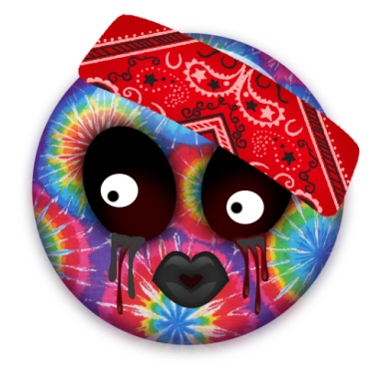

(typical participant workshops/survey who had immediate ‘crisis’ issues or concerns)

An Australian aged 16 to 25 years, Dana was seeking service support for housing, alcohol and drug issues, mental health problems or identity concerns. Typically, s/he identified as Australian, Caucasian but also as Aboriginal and Torres Strait Islander, or from African nations.

S/he resides in metropolitan regions in supported accommodation but also has experienced frequent homelessness or ‘coach surfing’. Dana was self-sufficient in that s/he was more likely not living within a family home or sustained by familial support structures. Predominately s/he had completed grade ten but was unable to work or was looking for work.

Dana had a smartphone and sometimes used apps and websites both online and offline depending on access to the internet, and the data available. The type of apps s/he will use will be information apps, entertainment (music), social media apps and some games.

S/he may seek advice on the internet about how s/he was feeling, and for health issues, but will phone someone if in crisis, and in general, does not expect to access case-management notes. The relationship s/he has with a worker or counsellor was very important and was based on mutuality.

Wellbeing for Dana was about being happy and healthy, and included having access to basic needs that is, money, food, time and sleep. Wellbeing is important for Dana because, *it makes life worth living.*

# RESULTS

## Key topic areas

### Data collection and analysis map

The key topic areas for the study were represented graphically to guide and determine the connection between the questions being asked and the methods used to elicit understanding. The range of questions identified under each key topic area included both interpretative and evaluative questions. The map below was used as a tool for collecting, interpreting, combining and presenting the results of the analysis.

|  |  |  |  |
| --- | --- | --- | --- |
| **Key topic area** | **Method of data collection** | | **Item** |
| *Wellbeing* | | | |
| *What are young people’s perspectives of wellbeing?* | Survey/ Workshop/  Focus group | | Workshop /Focus group,  T1, T2, T3, T4  Survey Q4, Q16-21 |
| * *What are the bits of wellbeing that are most relevant to the everydayness in young people’s life contexts?* | Workshop /Focus group,  T1, T3, T2  Survey Q27-45 |
| *What do young people say enables or impedes access to services to support young people’s wellbeing goals?* | Survey/ Workshop/ Focus group | | Workshop /Focus group T5, T9  Survey Q38, Q44, Q48-49 |
| *How does young people’s understanding of wellbeing resonate with digital service delivery?* | Workshop/  Focus group/ combined data | | Workshop /focus group  Survey Q22-25 Q53 |
| *Engagement, relationships and connection* | | | |
| *How do young people describe their engagement/relationship/connection with services to support wellbeing?* | Survey Workshop/  Focus group | | Workshop/Focus group T6-7  Survey Q47 |
| *What do young people (say they) want from their relationship with service providers to support their goals for wellbeing?* | Survey  Workshop/ Focus group | | Workshop/focus group T3, T6-7  Survey Q50-52 |
| *What sort of control do young people want to have over their connections and relationships for wellbeing with service providers through digital technologies?* | Survey Workshop/ Focus group | | Workshop/focus group T 5-7  Survey Q12-13, Q 24 |
| *Digital technologies* | | | |
| *What kinds of devices are emphasised in what young people say is their current digital and technological usage?* | Survey  Workshop | Survey Q5, Q6 | |
| *How do young people conceive their current digital and technological usage? e.g for entertainment, as a way to plan things, to access information etc.* | Survey | Survey Q9, Q10, Q11, Q12, Q13 | |
| *What interactions are emphasised in what young people say is their current digital and technological usage?* | Survey/ Workshop | Survey Q5,Q7, Q8, Q9, Q10, Q11, Q13, Q12, Q14, Q15, Q17  Workshop/Focus GroupT4 | |
| *How do young people currently use technology to improve their wellbeing?*  *e.g self-help, motivation, information, education, peer connections, worker connections* | Survey  Workshop/  Focus group | Survey, Q11, Q17, Q18, Q19, Q24, Q25, Q26  Workshop/Focus Group  T3, T4, T5, T7 | |
| *How can technology reach young people where they feel comfortable and in a way that is acceptable to them?* | Survey Workshop/  Focus group | Survey Q12, Q17, Q18, Q19  Workshops-T3, T5  Observation – doing apps | |
| * *What digital features do young people want/need?* | Survey Q8, Q14, Q17, Q26  Workshop/ Focus group T3, T5 | |
| * *How do young people currently maintain and develop relationships through technology?* | Survey Q15, Q18, Q19  Workshop/ Focus group T3 | |
| * *What features would motivate young people to use digital tools as an extension of wellbeing services?* | Survey Q10, Q11, Q12, Q19, Q52, Q53  Workshop/ Focus group T3,T4, T5, T7, T8 | |
| * *What wifi connectivity functionality do young people want/need?* | Survey Q7,  Workshop /Focus group | |
| *What technological functionalities are important for young people to interact with their own case plans in client management systems?* | Survey  Workshops/Focus group | Survey Q6, Q7, Q17, Q50  Workshop/Focus group T3, T5, T9, T7  Observation | |
| *Co-design* | | | |
| *What sort of control do young people want to have in the design, development and implementation of well-being service models which integrate digital technologies aimed at supporting young people’s wellbeing?* | Workshop | Observation  Workshop/Focus group T7, T5, T9 | |
| *What key commitments and practices (ways of thinking and responding) are needed to enable processes of mutual discovery, learning, and design in the development of wellbeing digital technologies?* | Workshop | Observation imagery  Workshop/ Focus group T5, T7, T9 | |
| *How can co-design be orgranised to enable more granular, nuanced and ongoing forms of innovative technologies that support young people and their relationships with service providers?* | Workshop/ focus group | Observation  Workshop/Focus group T2, T5, T9 | |

Table 1. Data collection and analysis map

This consultation sought to assess the young people’s perspectives of wellbeing, and creative and innovative approaches for the generation of digital tools that strengthen the effectiveness of worker-young person support processes. Below we report on the learnings under each key topic areas and discuss the interpretative and evaluative meanings and what these entail for use in future research and digital technology development.

## Wellbeing

Three questions framed the inquiry to examine young people’s wellbeing. These were

1. What are young people’s perspectives of wellbeing?
2. What do young people say enables or impedes access to services to support young people’s wellbeing goals?
3. What are the implications of young people’s perspectives of ‘being well’’ for service provider’s understanding of wellbeing? How do these resonate with digital service delivery?

### What are young people’s perspectives of wellbeing?

#### Feeling good and going well

Participants were asked about their wellbeing through a number of items across the three methods of data collection. In the previous section three profiles outline the more generalised circumstances or profile of participants across the data. The profiles are,

* Kasey, the typical young woman;
* Luke, the typical young man; and
* Dana, the typical young person dealing with immediate issues or concerns.

A general picture is summarised in each profile and indicates that typically, the participants felt good and that life was going well. This is also evidenced in the engendered profile of young people dealing with immediate issues or concerns. As such, wellbeing was understood as important because

“…it helps having a positive outlook”.

|  |  |  |  |  |  |  |  |
| --- | --- | --- | --- | --- | --- | --- | --- |
| **Answer Options** | **strongly disagree** |  |  |  | **strongly agree** | **Rating Average** | **Response Count** |
|  | 47 | 76 | 92 | 68 | 27 | 2.85 | 310 |
| ***answered question*** | | | | | | | **310** |
| ***skipped question*** | | | | | | | **62** |

Young people’s responses to the survey items seeking to understand individual experiences of wellbeing (questions 16 to 20) indicated that on a scale of 1-5 with 1 being strongly disagree and 5 being strongly agree, the participants recorded just over 3 out of 5 stars. For example, 63% of respondents rated “My life is going well” with 3 stars or more. 86% of responses to “I have good family and friends’ rated the statement with 3 stars or more. However, where asked if their life is just right, 73% rated this statement at 3 stars or below, indicating that they disagreed that their life is just right. They also were asked if they had what they need in life and scored on average just above 2.85 stars indicating that they may be coping but not necessarily thriving with life as it is (Chart 3). Question 21 in the survey furthermore, asked participants if they felt “that they were able to get the help they needed from others to live

their life well”, 38% indicated that this occurred sometimes.

Chart 3. Q20 I have what I want in life

Suggested in this data is that the young people’s individual feelings and connections of wellbeing may not necessarily be interlinked to their expectations for what they want in life. Indeed, demonstrated in the data were certain tensions and contradictions present in young people’s perspectives of wellbeing.

For example, when we consider ‘Dana’s’ profile (p.32), young people’s perspectives of wellbeing are problematic in relation to the conflicts that transpire in the life of a typical young person dealing with immediate issues or concerns. The data drawn from the workshops particularly demonstrated that “*the term ‘wellbeing’ was not relevant or understood by participants even with scaffolding and explanation*” (Facilitator observation). Young people’s orientations of wellbeing were more closely aligned to health aspects. This was conspicuous in the use of the word health often instead of wellbeing. During a drawing and writing activity in which participants were asked to illustrate the ‘best version of themselves’ conversations covered topics such as feeling normal and happy, the enjoyment gained from drug taking, respect and trust, privacy, food, money, accommodation and homelessness, friends and relationships, and balancing varied aspects of life (Figures 1 & 2). *“Some of the participants began the drawing activity by focusing on the things that distract them (e.g. drugs) from the problems they were experiencing (e.g. homelessness) so that they may have a sense of happiness or release. Their drawing/writing then progressed to identify strengths or the support they required such as, BYS workers, mates and relationships. Some of the young people reflected on the past and potential futures e.g. having a home, hygiene, food etc.”* (Facilitator observation). In these data we can distinguish that young people’s needs, values, resources and circumstances provide shifting provocation to the bits of wellbeing most relevant to their immediate and everyday perceptions.



Figure 1. A personal emoji from workshop task 4

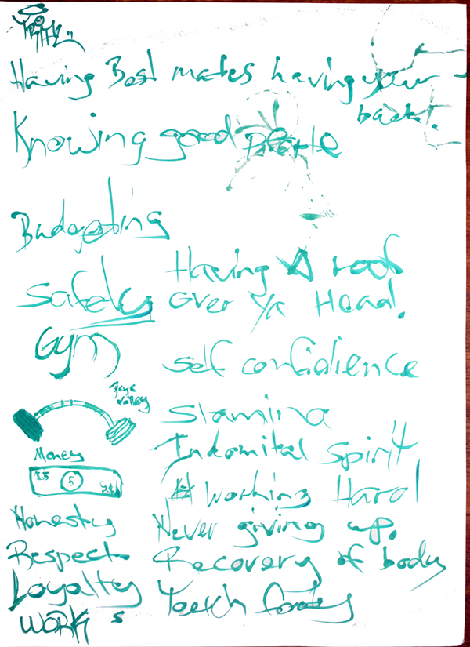

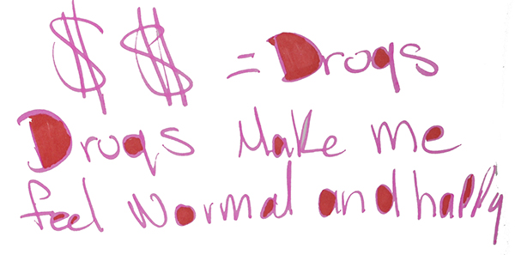

Figure 2 - Drawing and writing activity workshop 1 T2

#### The bits of wellbeing most relevant to everydayness

A sub-question exploring young people’s perspective of wellbeing, aimed to evoke the everydayness of wellbeing in young people’s lives. To answer, *What are the bits of wellbeing that are most relevant to the everydayness in young people’s life contexts?,* we examined multi-dimensional qualities and recursive properties in what young people said they think wellbeing is.

Positive Coping Doing Safe Okay Life Stable cool

Healthy emotional Physically comfortable Mentally positivity Spiritually grounded Self Happy peace Friends connected Socially family resilient balanced nourished survive fulfilled care Loved content Health Basic Needs Met Feeling body Mind cognitive satisfaction wholefully

Support Holistic Taking Care vitality outlook

Figure 3 Q4 Word cloud from the question ’ Can you please finish the sentence "wellbeing is..."’

The above word cloud (Figure 3) illustrates the words used by respondents to state what wellbeing is. ‘Health and healthy’ combined were the most frequent word/phrase used in their responses. This was closely followed by ‘happy or happiness’ and thirdly by the phrase ‘physically and mentally’. While on the surface these bits of wellbeing blend with components foregrounded in global and national indexes measuring wellbeing (Wright and Mcleod, 2016), further probing into what is needed to have wellbeing highlighted young people’s perceptions of wellbeing as,

* A state; (e.g. being, able, to have)

“You don't need things. You are born with some sort of wellbeing it just takes other people to help you grow ur wellbeing.”

“…to find myself.”

“…to me happy”

* A right;

“Basic human rights, family and friend support, access to services like kids help line and psychologists.”

“…to have a home, bed, family, friends, money, education, food and phone.”

“…affordable mental health services.”

* An attitude;

“To have wellbeing I need to make sure I take daily risks and I identify my strengths and disadvantages.”

“… to have good self esteem.”

“…to surround myself with good people, and good thoughts.”

* Self-determined

“…to be positive and take care of my mind.”

“…to deal with stress and be moving forward.”

“Confidence in yourself, happy and stay positive.”

To understand the context in which young people think that wellbeing is important in their everyday lives, participants were asked to finish the sentence “*Wellbeing is important because…’*. In their responses many of the participants focused on what life ‘without’ wellbeing would be like stating,

“The absence of positive wellbeing can cause mental illness.”

“You won't enjoy life.”

“You shrink away if you don’t have it.”

“Without it you are in danger and risk of dying.”

In all, their responses draw our attention to wellbeing as fundamentally relevant to the everydayness in their life contexts. This is clearly expressed in the following statements,

“I don't want to live a pointless life.”

“It's how you function as a human being.”

“It's a foundation for everything we experience.”

Critical to interpretations of young people’s perspectives of wellbeing is that their understanding is complex, multi-faceted and deeply in tune to ideas of meaning and value as a human being. Specifically, as one young person shared,

“We all need our own kind and definitions of wellbeing to survive.”

### What do young people say enables or impedes access to services to support young people’s wellbeing goals?

*Safe, heard and respected in person*

Of uppermost importance for young people was the need for services to respect and listen to where young people are at. During a workshop conversation about why they access services at BYS participants explained,

*Participant (male) They sit there and ask us how we are going and ask us how we are doing. Other services don’t do that.*

*Facilitator1: Ok so is that a good thing for people to ask you how you are doing?*

*Participant (male): Oh it would be nice to sit down and have a conversation about how you are going.*

Response to question 38 in the survey highlighted the importance of being treated with respect. Participants were asked to rate what they think is important for wellbeing and what they need to feel good about themselves and their life. 96% rated *being treated with respect* with 3 stars or more (Chart 4). 59% rated *to feel good about themselves and their life* as most important for their wellbeing.



Figure 4. A personal emoji from focus groups task 4

|  |  |  |  |  |  |  |  |  |  |  |  |  |  |
| --- | --- | --- | --- | --- | --- | --- | --- | --- | --- | --- | --- | --- | --- |
| **being treated with respect** | | | | | | | | | | | | | |
| **Answer Options** | | **not at all important** | |  | |  | |  | **most important** | | **Rating Average** | | **Response Count** |
|  | 4 | | 9 | | 31 | | 77 | | 172 | 4.38 | | | 293 |
| ***answered question*** | | | | | | | | | | | | **293** | |
| ***skipped question*** | | | | | | | | | | | | **79** | |

Chart 4. Q38 being treated with respect

Expanding on the importance of respect as someone who listens, young people’s preference to directly speak with someone about wellbeing goals, concerns or problems was additionally supported in the data collected in the survey. When participants were asked how they last *spoke to someone like a counsellor/ youthworker (or other person who helped me)* of the 272 responses more than half responded *‘in person’*.

Chart 5. Q48. The last time I spoke to someone like a counsellor/youthworker (or other person who helped me), it was...

Importantly, the data suggest that after they last spoke with a counsellor/youthworker (or other person who helped them), they felt better able to deal with their problems than before. The issues or problems that young people more generally needed help for included, how they were feeling (86%), school issues (79%), problems with friends or family (78%), health (64%), body image (62%) and socialising (51%). The young people participating in the workshops and focus groups sought help for housing, health care, crisis support and employment. The facilitator at one of the workshops observed,

Facilitator: So what I am hearing is that there is all of this stuff but really with the gist of it, housing is important, as is being safe, heard and respected.

Participants: Yeap!

Participants in both the workshops and focus groups further specified that regular contact with caseworkers is necessary to maintain stable housing. They advocated for workers to…

“Come and see us once a week.”

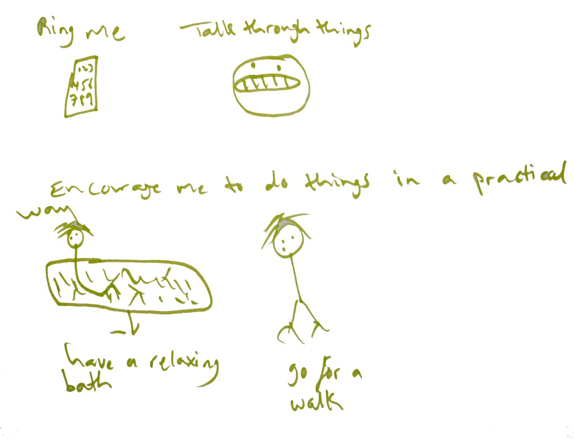

Figure 5. Drawing from focus group illustrating requisite for contact from workers

For a young woman in the focus group contact with workers was about providing everyday support to stay on track with her goals, as illustrated in her drawing (Figure 6). 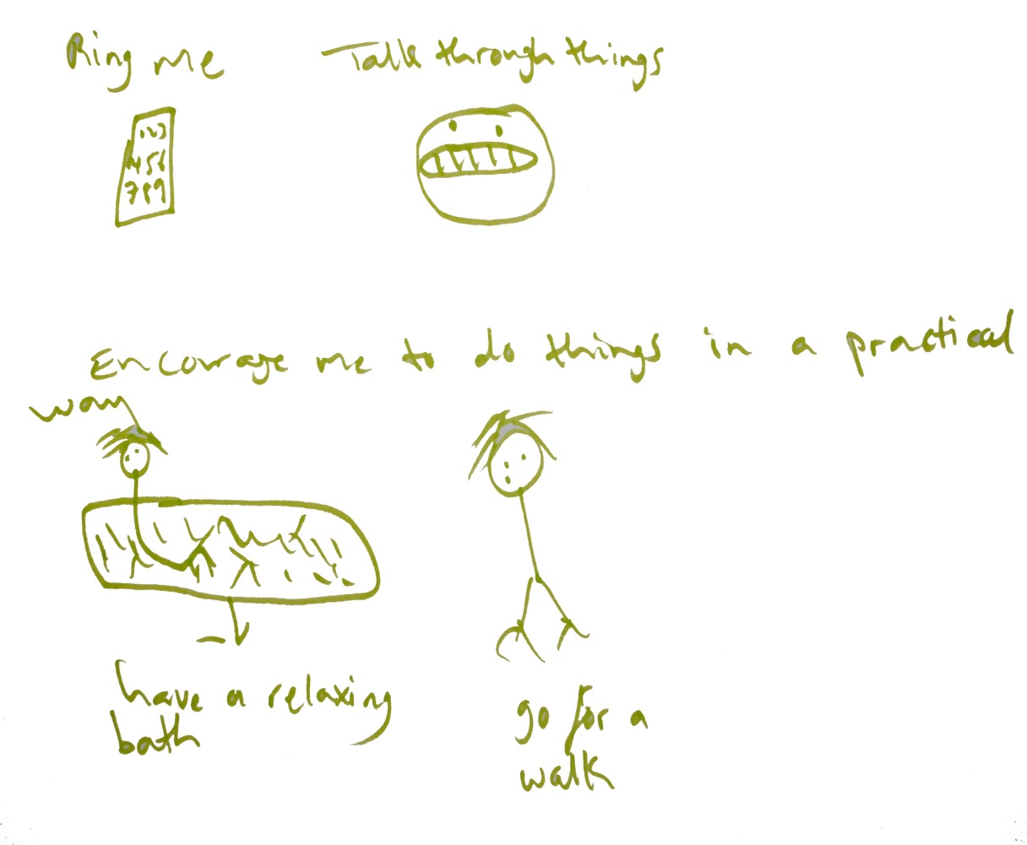

Figure 6. Drawing illustrating support for everyday wellbeing goals

This perspective supports findings which suggest young people need personal contact and practical support to help them achieve their wellbeing goals and is acknowledged in other literature (Gibson, Cartwright, Kerrisk, Campbell, and Seymour, 2016; Singh, Anderson, Liabo, and Ganeshamoorthy, 2016). Further, it could be argued, worker and agency support is of utmost important when there is little or no parental involvement in the young person’s life and in which they do not have the social capital scaffolding (intimacy and belonging) associated with family.

Wellbeing was described by a young woman in the focus groups as *“all pretty connected”* to health, wealth, mental and physical circumstances. As such, a male participant explained,

“… in some aspects I’d like it (services) to be all in (a) one stop thing, but I would like to personalise it.”

Hence, young people indicated their preference for access to a variety of services available in one place, or through one platform to enable support for their wellbeing goals.

#### The costs

Barriers to service use were apparent in the young people’s conversations about services in our workshop and focus group data. Young people mentioned charges involved with accessing services as well as the costs associated with travel as obstructions to mainstream health care services. A couple of participants explained,

Some medical surgeries, I know there are some that bulk billing out there. But some medical surgeries treat you and you’ve got a pay. Like you can come here, we can come here and get dressed for free. My GP will charge for dressing.

“Its gona cost a lot of money. Plus you’ve gota have travel fare on top of that.”

Consequently, young people felt access to the free health care workers at BYS should be more available specifically to enable better access to their health needs of wellbeing and to lessen negative and stigmatised feelings when seeking help in other services.

“(The nurse is) here four days a week, it should be five times.”

The cost associated with accessing support or self-help through digital tools such as free app, free services and add ons were also emphasised in responses by participants.

#### Treated fairly

76% of participants in the survey rated being treated fairly as a young person as always and absolutely always connected to their sense of wellbeing. Young people in the workshop indicated that they did not always feel treated fairly when they access services for their health needs.

“I’ve been to so many places where I have felt judged. Yeah- yeah, yeah, yeah. You get looked up like up and down. Even from surgeries they don’t actually stich up self-harm wounds anymore- they just send you up to hospital. It’s because um apparently they are wasting resources. They don’t want to waste their limited resources on someone that is self-harming.”

Being treated fairly included being valued as worthy of the resources and to be treated with care and compassion. Being treated fairly also incorporated an ability to freely express emotions without judgement therefore, enabling young people to feel confident to reach out for help.

### What are the implications of young people’s perspectives of ‘being well’’ for service provider’s understanding of wellbeing? How do these resonate with digital service delivery?

Young people’s perceptions of wellbeing as a state, a right, an attitude and self-determined suggest that services must extend health and emotional frameworks to also attend to the importance of self-determination and human rights for ‘being well’. Self-determination, for example, stems from opportunities to exercise control, voice, and choice and is fostered by empowerment or enablement processes (Evans and Prilleltensky, 2007). As such, digital strategies or interventions should encompass practices that encourage young people’s capacity for agency, support, knowledge and responsibility in ways which meet individual, interdependent and system based needs of young people.

Digital service delivery which embodies only feelings, behavioural cognition, and psychological experiences of wellbeing neglect the various connections and resources that contribute to young people’s multi-faceted perspectives of wellbeing. Young people in the workshops emphasised conditions connected to being well which are,

“really important for your wellbeing – like to be clean, having clean clothes, food, sleep, medical attention,”

Being transient or homeless directly impacts young people’s capacity to access these resources for being well. Several young people explained,

*Participant (male): Well if you are on the streets it is hard to not have a shower, to keep clean...*

*Participant (bisexual): …to eat*

*Participant (male): …to get money to fucken charge your phone*

*Participant (female): …to even have shit as well. Let’s be honest and you have to find someplace.*

Not supporting structural arrangements to enhance these rights-based conditions impinges on the core wellbeing of the young person.

From 199 responses to question 53 in the survey a range of tangible qualities can be determined to support the development of digital service tools. The chart below categorises the free text responses into ten prominent areas.

Chart 6. Q53 If I was going to use a really good digital app or website I would like it to have…

The data across all methods indicated that digital service delivery must primarily be built on personal interactions. To resonate with young people’s multi-faceted understanding of wellbeing, digital interventions should include opportunities to engage and make connections across networks (services, workers and peers), facilities and resources. For example, through providing interactive information and advice; games or challenges to ‘*distract them from problems’*; ‘*forums to connect with others’* (peers and workers); providing digital updates on when and where to access resources (e.g. ‘*the orange (van) washing machine van going around’)*; goal setting, monitoring achievements and everyday outlooks of wellbeing; and providing a life line to caseworkers in times of crisis.

## Engagement, relationships and connection

Three questions guided interpretation of young people’s perspectives of engagement, relationship and connection. These were

1. How do young people describe their engagement/relationship/connection with services to support wellbeing?
2. What do young people (say they) want from their relationship with service providers to support their goals for wellbeing?
3. What sort of control do young people want to have over their connections and relationships with wellbeing service providers through digital technologies?

### How do young people describe their engagement/relationship/connection with services to support wellbeing?

#### Trust, mutuality and reciprocality

Question 22 in the survey asked young people where they went to get advice or help with problems. There were 296 responses to this question. This was a free text response question and word response. Analysis revealed that 15% of respondents noted that they used Kids Helpline and 1 % used BYS (Chart 7). This most likely is based on the platforms of responses, in that most were online through Kids Helpline and respondents were from across Australia. Just under 41% said that they sought help from family or friends conceivably, indicating that trust and mutuality, and intimacy and belonging are key priorities for young people when seeking support. This also provides critical insight to the significance of interdependent connections. Including, family and peer educational programs and where possible opportunities for familial and peer connections as strategies to support young people’s wellbeing is an important consideration for digital service delivery.

Chart 7. Q23 For help with my problem/s I went to (please tell us who and or where you went for help)

In any case, it was evident that trust is an important feature for engagement with services to support wellbeing. The significance of trust and faith in-self was documented in a young person’s explanation and drawing (Figure 7), in which they connected faith to belief in ones-self.

*Facilitator: So what does faith do for you? What is faith?*

*Participant (male): Well you gotta {trust}, you gotta have faith that’s gotta work.*

*Facilitator: So it’s like a belief in yourself?*

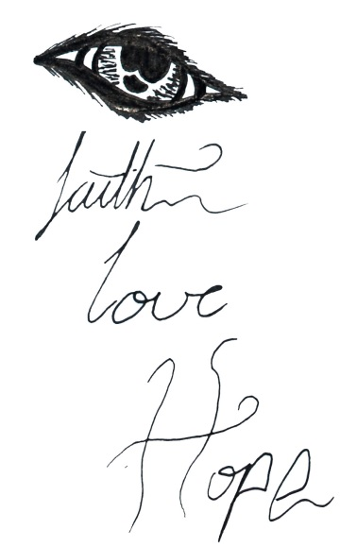

Figure 7. Drawing from workshop

The two images below (Figure 8) further capture young people’s idea of trust as connected to wellbeing, mental health, communication, support, encouragement, belief, understanding, freedom and love. These things are valued and sought after by young people in their interactions with services and workers to support their wellbeing goals.

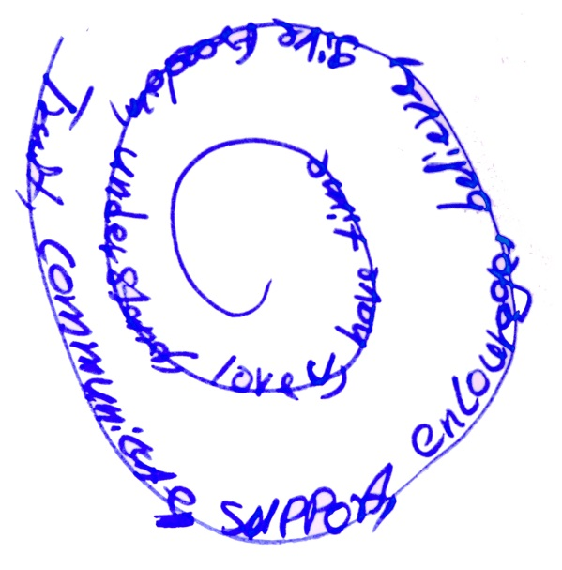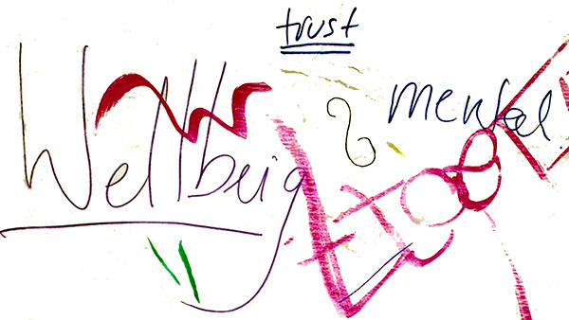

Figure 8. Focus group and workshop images

As noted previously, young people’s engagement with BYS was connected to respect and being treated fairly. Young people were cognitive of the benefits for their wellbeing of being treated fairly, and understood BYS as a ‘youth friendly’ service. A young person stated,

“I am here because I get the help I need without being treated like a piece of shit and being a victim, being blamed and all this shit.”

Young people’s perspective of youth friendly health services has been evidenced to include accessibility, staff attitude, communication, expertise and competency, guideline-driven care, age appropriateness, youth involvement/participation and health outcomes (Ambresin, Bennett, Patton, Sanci, and Sawyer, 2013). From a youth friendly perspective, young people participating in the consultation described their expectations for digital service delivery as needing,

“…more than two gender options when signing up”

“A place for everyone to go.. including LGBTQIA”

“Information on the counsellor, rules and regulations”

“…that we can't be judged in our situations”

“Set out in a way people with disabilities like myself can understand the information”

“Relevance to all ages”

“The feeling of being comfortable, like a safe space”

### What do young people (say they) want from their relationship with service providers to support their goals for wellbeing?

#### To talk through it

Many of the young people participating in the focus groups and workshops described ‘talking through it’ as key quality of their engagement with workers that supports their wellbeing. Exploration of currently available digital wellbeing apps emphasised young people’s preference for using tools that supported a continuance between sessions with their workers and that would extend their relationships with workers. A respondent in the survey said she wanted the ability,

“…to allow my therapist or doctor to easily access any information I've input in between appointments”

For another young person participating in the workshops, the idea of writing things down in an online journal offered the chance to,

“…actually make me feel good. Like checking in”

Communication between sessions with workers was seen as a way to enhance their relationships with workers and to communicate what is going on for the young person. A number of participant in the workshops devised very astute and practical ideas for the development of a useful and engaging app. One such process involved using emojis to communicate what is going on in their daily life and to express their feelings to workers. This involved more than using the emojis as an index of positivity, it also, embraced engaging, creative and interactive dialogue with creative expression a highlighted feature. Figure 9 represents how one young woman imagined the flow of communication might work using emojis to communicate with her worker.

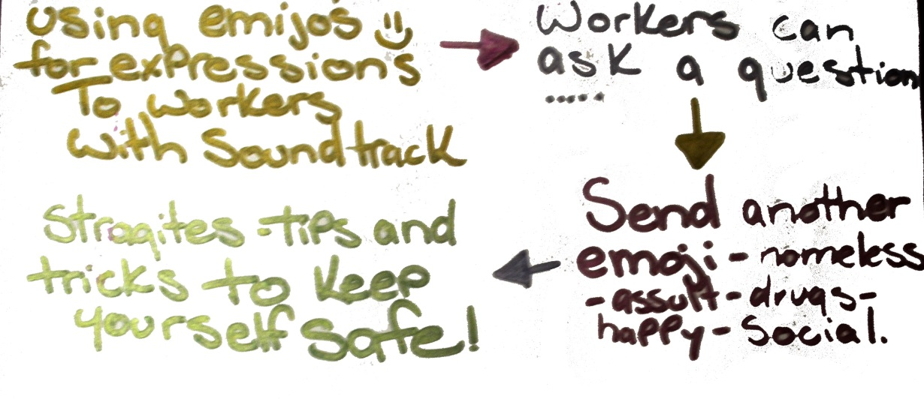

Figure 9. . Using emojis map design for an app workshop T 9

A similar concept was captured in a conversation between another workshop participant and the facilitator. They talked about using a ‘colour wheel of emotions’ as a way for the young person to communicate with their worker.

*Facilitator: So if someone was managing your case, if you were able to show them the problems that you are having.*

*Participant: Well its all the different emotions*

*Facilitator1: So if you could just flick through a random*

*Facilitator1: And you find this useful*

*Participant: Yeah it helps me explain*

*Facilitator1: So if you had that on an app that would be helpful*

*Participant: Yeap*

The YouEngage consultation also examined what young people required as supportive and accessible connections with service providers. Several young people highlighted an expectation that digital tools would enable immediate and accessible connections to help. Young people explained,

“You also need like a 24 hour thing. Let’s say I am having a really depressed night I am still awake at three o’clock in the morning.”

“…if there literally, was probably like a panic button that I could brace so it would pretty much go to my issues are that I would have specified at some point. So if I have been like arh feeling anxious or something like that and I am having a like panic attack, I’d like there to be a panic button that I could press to sort of help that would basically funnel me to the right place.”

While they did understand that workers are unable to respond around the clock they still anticipated and expressed a preference that the person responding to them through digital technologies knew them.

Further supporting young people’s expectations and need to develop meaningful relationships with workers, 86% of respondents (n=272) to question 51 of the survey agreed that it was true that it is important to speak with the same person each time. In question 50 of the survey, 63% of respondents indicated that they want to have the ability to contact their workers or counsellor between sessions.

While it might be conceivable that a young person’s digital profile, could be transferred between workers it was felt that personal contact was still required in order to,

“have the new caseworker get to know you as well.”

One female participant explained,

“Yeah but you still… they don’t know how you have been feeling about it. They don’t know how… and then the next worker will be like oh do you have any coping methods…”

Young people expect to maintain direct personal contact as an essential component their engagement with workers to support their goals for wellbeing. Digital engagement was understood as providing an extension of their direct contact with workers.

### What sort of control do young people want to have over their connections and relationships for wellbeing with service providers through digital technologies?

Nuanced across the data was how young people want to be in control of their connections and relationships to support their wellbeing through digital technologies. Across the data young people’s need to maintain control was apparent in how they described their interactions to seek help for their problems and in their perspective of wellbeing as self-determined. For example, in question 24 of the survey participants agreed that there was a lot of information on the internet to help them solve problems. 54% of respondents to question 12 indicated they use self-help or health monitoring apps. 78% of respondents in question 13, used apps or websites when they need to know something and 52% said they used apps or websites to get help to deal with stuff in the same question. We can infer from this data that they sustain a reasonable degree of self-reliance and decision making regarding problem solving in their life. A young person stated they wanted,

“Access to helpful ways to improve my life, for me to be in control, a progress thing”

Therefore, the integration of digital tools that promote youth wellbeing and support the effectiveness of worker-young person support processes should reinforce interactions that extend tenets of self-determination and the young person’s control. It should be noted that self-determination does not equate to self-help. To satisfy self-determination principles young people require access to information to be informed, opportunities for learning and to participate in ongoing dialogues, be supported in choosing and attaining goals, and receive positive feedback (Krabbenborg, Boersma, van der Veld, Vollebergh, and Wolf, 2017).

## Digital technologies

Six questions framed our interpretation and evaluation of young people’s knowledge of different app and online technologies and their perceptions of digital technology solutions to promote youth wellbeing. These were

1. What kinds of devices are emphasised in what young people say is their current digital and technological usage?
2. How do young people conceive their current digital and technological usage? e.g for entertainment, as a way to plan things, to access information etc.
3. What interactions are emphasised in what young people say is their current digital and technological usage?
4. How do young people currently use technology to improve their wellbeing?
5. How can technology reach young people where they feel comfortable and in a way that is acceptable to them?
6. What technological functionalities are important for young people to interact with their own case plans in client management systems?

### What kinds of devices are emphasised in what young people say is their current digital and technological usage?

The YouEngage consultation sought to respond to this question using the survey, for the most part. Respondents were asked about their current digital usage and there were 329 responses in question 6. Just over half of all respondants (n=170) said that they most often use a smartphone to access the internet. 14% (n=46) use a lap top, 7% (n=22), and 5% (n=15) use an iPad. A total of 20% (n=66) said that they use all of these and 3% (n=10) provided ‘other’ responses. These consisted of ‘tablet’ or brand identified smartphone, one person said that they use X-Box. Questions in the other data collection methods highlighted that smartphones were the defualt device to access online information and connections. Online usage was dependent on access to data. One participant explained,

“I don’t really have a very good plan, that’s… I am always at home so it’s cheaper for me to use the wifi and I message and stuff like that.”

In any event, the most common way partipants access the internet is by using smartphones, followed by laptops or desk top comupters. It appears that ipad and tablet are less used or accessed than smartphones.

### How do young people conceive their current digital and technological usage? e.g. for entertainment, as a way to plan things, to access information etc.

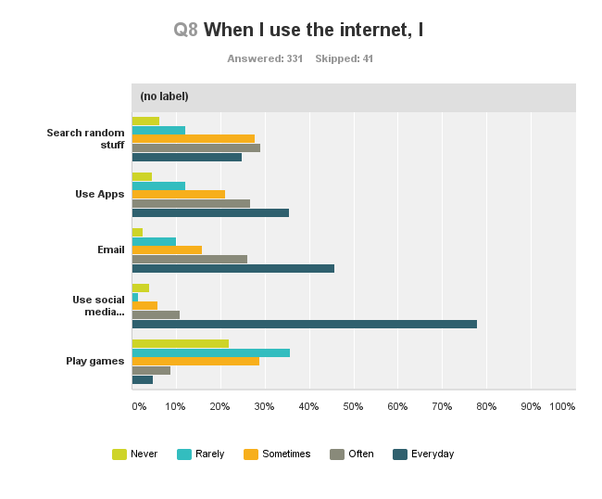

Chart 8. Q8 When I use the internet, I

In question 8 of the survey, participants were asked about what they commonly use the internet for. A number of choices were presented along with a free text response field.

Overwhelmingly, participants(n252) conceived their usage for social media to be an everyday occurrence (Chart 8). Responses (n36) to the free text field highlighted other reasons young people described for their internet usage including, for homework, education, study and school work or research (66% combined), for assistance with their mental health (10% combined), to watch Youtube for music or entertainment (16.7%), and for general assistance with life (5%).

[Mental Health](https://www.surveymonkey.net/analyze/R02SRBybkPQeAxJj3OG7rtd51RzuV8ok7qJ6pdGberfhLD_2BQdnyvMdokitRbOkPB)

[Music](https://www.surveymonkey.net/analyze/R02SRBybkPQeAxJj3OG7rtd51RzuV8ok7qJ6pdGberfhLD_2BQdnyvMdokitRbOkPB) [Homework](https://www.surveymonkey.net/analyze/R02SRBybkPQeAxJj3OG7rtd51RzuV8ok7qJ6pdGberfhLD_2BQdnyvMdokitRbOkPB) [Education](https://www.surveymonkey.net/analyze/R02SRBybkPQeAxJj3OG7rtd51RzuV8ok7qJ6pdGberfhLD_2BQdnyvMdokitRbOkPB) [Research](https://www.surveymonkey.net/analyze/R02SRBybkPQeAxJj3OG7rtd51RzuV8ok7qJ6pdGberfhLD_2BQdnyvMdokitRbOkPB) [Life](https://www.surveymonkey.net/analyze/R02SRBybkPQeAxJj3OG7rtd51RzuV8ok7qJ6pdGberfhLD_2BQdnyvMdokitRbOkPB) [School Work](https://www.surveymonkey.net/analyze/R02SRBybkPQeAxJj3OG7rtd51RzuV8ok7qJ6pdGberfhLD_2BQdnyvMdokitRbOkPB) [Headspace](https://www.surveymonkey.net/analyze/R02SRBybkPQeAxJj3OG7rtd51RzuV8ok7qJ6pdGberfhLD_2BQdnyvMdokitRbOkPB) [Youtube](https://www.surveymonkey.net/analyze/R02SRBybkPQeAxJj3OG7rtd51RzuV8ok7qJ6pdGberfhLD_2BQdnyvMdokitRbOkPB) [Study](https://www.surveymonkey.net/analyze/R02SRBybkPQeAxJj3OG7rtd51RzuV8ok7qJ6pdGberfhLD_2BQdnyvMdokitRbOkPB)

Figure 10. Q8 word cloud “When I use the internet, I…”

### What interactions are emphasised in what young people say is their current digital and technological usage?

Question 6 of the survey was used to directly evaluate young people’s interactions with digital and technological usage. There were 332 responses to this item. Overwhelming, 94% (n=310) of participants said that they use the Internet every day, while 5.7% (n=19) use it a few times a week and 0.9% (n=3) use it once a week. There were 0.0% responses whereby participants said that they never use the Internet. This is consistent with much of the available research on general Internet use in Australia and other western countries among this cohort.

Through a matrix in question 7 of the survey, respondents (n=332) provided information regarding where they use the Internet and how frequently. On average, respondents use the Internet at home (n=330), every day (n=282). The next most frequent use occurred at school (n=328), every day (n=179). Respondents also access the Internet using friends resources every day (n=44). Interestingly, 101 said that they would never use the internet in the library, and 100 would rarely use the internet in the library, while 75 never use public hotpots and 107 rarely use public hotspots.

When using apps, 74% of participants (n=246), will use apps in both online and offline modes where possible. 23% (n=75) use them only online while only 3% (n=10) will use apps only off line (Question 9). This indicates that participants will most likely use an app that they can download and use offline as well as online.

To ascertain the type of interactions which are emphasised in what young people say is their current usage with regard to the type of platform used question ten asked respondents to name their favourite game. Interpretation requires a search of the specific platforms uses to develop each game. This is beyond the scope of the consultation but is important in the future development of website or activities to best match ‘identified popular platforms’. Frequency of the types of games is presented in this report for future evaluation. It should be noted that most respondents use the Internet to access social media or may engage in gaming only at a minimal level. A key factor with this response is likely to be gender based, given that 323 respondents were female and 29 were male.

When respondents did name a game, text analysis revealed that Sims was the most popular identified game (5%, n=16), followed closely by Candy Crush (4%, n=14), these were followed by Pokémon (3%, n=8), Episode (2%, n=7), Minecraft and Colour Switch (2%, n=6 each) and Solitaire, Hay day and Subway (1%, n=5 each).

Flow Run2 Solitaire  Minecraft Dash

 Episode Facebook  Pokemon

Clash Candy Crush League of Legends

Pool  Subway Sims  Word Fiends

Call  Colour Switch Mario Hay Day

Figure 11. Q10 word cloud When I play games using digital technologies, my favourite games is

Participants were asked to provide a reason for why they play games in question 11. Most respondents (n=150) indicated that they liked to solve problems. Some of the other reasons young people offered included,

“…to entertain me when I'm bored”

“…to give me a break from study”

“…try to beat my brothers highscore”

“I like learning languages”

“Feeds my sense of adventure because I don’t travel much”

### How do young people currently use technology to improve their wellbeing?

Young people said they used both apps and websites when seeking help for their wellbeing. Generally, the data indicated that participants would use apps to find quick response, while they would expect to be referred to websites for additional or more detailed information.



Chart 9. Q25 I have used these to help deal with problems

Survey results indicate that respondents would most likely read information on a website, while they would seek interactive platforms on both websites and apps, with apps being most used for games and general resources. This is highlighted below (Chart 10), which shows that respondents would use both apps and websites to access information.

Chart 10. Q26 If you could use an app or website to help you deal with problems, what would the thing you most likely use look like?

Participants identified a range of apps that they use to help them with wellbeing or health such as, Fast Habit, Nike Training Club, Anki, Fitbit, Beyond blue safety plan, Koko, Recolour

Smiling mind, Mindshift and Pacifica. Question 53 in the survey sought to understand what young people would look for to help them with their wellbeing goals and needs using technology. The following word cloud summarises what young people said they would like to have in a good app or website for their wellbeing (Figure 12).

Journaling Ways to Improve Services

Simple Interface Colours Positive Free Quotes useAbility Friends Interactive Button Tracking Connect Chat PrivateTips

Design Good Graphics safe Privacy

Games Fitbit Access Goals Options

Fitness Pal Progress Mental Health Localised

Inclusive Resources Video txt Messaging

Figure 12. Q53 If I was going to use a really good digital wellbeing app or website I would like it to have...

### How can technology reach young people where they feel comfortable and in a way that is acceptable to them?

The survey questions 12 through to 15 were designed to elicit the sort of features and qualities young people are currently using technology for. In addition, these questions sought to understand

* how young people maintain relationships through technology,
* the features or apps young people feel comfortable with.

There were 330 responses to question 12. Young people perceived that the apps they used were for entertainment (77%) closely followed by apps for social and fun qualities (74%). Expanding on the perceived uses, in question 13, when asked why they use apps or websites overwhelmingly, respondents indicated apps or websites are used to obtain information (80%). Importantly, many respondents (52%) also indicated they use apps or websites to get help to deal with stuff. There is a slight conflict in the responses between question 12 and 13 perhaps, indicating apps and websites offer different features and therefore different reasons for using them.

Question 14 sought to illicit the type of apps that young people are using. A significant proportion of respondents (n=309) identified that they use Snapchat, Facebook and Instagram. We can ascertain from their identified app use that young people were using apps to predominantly maintain social relationships; for entertainment and to access music; to obtain information more broadly; to monitor and plan travel; to monitor or track their health; and to play games. The following word cloud (Figure 13) illustrates the apps and frequency (by size) listed by respondents.

Wattpad Ibooks Music Spotify Episode

PTV uber Opal TripView

Twitter Instagram Snapchat

Facebook Pinterest

Kik Messenger Skype

Google Wikipedia SafariYouTube

Bubble Witch   ClashRoyale  Solitaire Period

Calm Headspace  Smiling Mind Nike Tracker

Figure 13. Q14 Can you name a couple of apps that you use?

Question 15 confirmed young people’s reasons for using these apps. 52% rated the use of apps as always important to keep in touch with friends.



Chart 11. Q15 On a scale of 1-5 (5 being always) I mostly use these apps for?

In terms of using technology to reach young people where they feel comfortable and in a way that is acceptable, tools that enable or enhance connection with friends, easy access to information and interactive learning opportunities are necessary.

### What technological functionalities are important for young people to interact with their own case plans in client management systems?

#### Connectivity

The workshop and focus group facilitators observed that for some participants access to wifi from a home connection, or via a plan were not available and typically the young people were opportunisitic in gaining access to internet connections as well as to power to charge their devices. A conversation from the workshops demonstrated the complexity of accessing these resources when homeless.

*Participant male 1: You know what the hardest thing about being on the streets is?*

*Participant (male) 2: What’s that?*

*Participant (male) 1: Finding somewhere to charge your phone…*

*Like I have a spot. But after midnight you can’t get in there. So you know where umm you can get into it from the station, go upstairs where the restaurant is. Before you hit…, go into the restaurant there is a power point up above.*

In general the young people seemed less aware of public places to access free connectivity and power charging for example through libraries or hotspots.

#### Privacy

Privacy important to young people and evidenced across the data. With regard to how safe respondents currently feel and also with whom they want to communicate, the chart below (Chart 12), shows that respondents 96% (n=276) of respondents felt that their information was safe online, and that they would want access to that information. However, this also appears to relate to the participants being able to talk to a person they feel they know, and who they feel knows them.

Chart 12. Q46 Think about how you want your privacy and information managed online by the counsellor/youthworker (or other person helping you). Do you think it is important to…

Varied levels of privacy will be an important consideration for the development of digital tools and the integration of client-management systems. Young people have different expectation and requirements for privacy across digital platforms and usage. For example, one male participant explained,

“…umm and then the other thing is that Facebook is good but, it has waves of how often people are using it. So like it is used many different ways and if they know their parents have access to the pages they may not be so … open about what they want to talk about.”

When asked if young people understand their privacy rights on social media cites another participant suggested,

“I think that young people have no idea what privacy rights are. They will just post whatever the hell they want and where ever they want and then get mad about it when someone finds out about it.”

#### Quick, fun, personal, social, interactive and a direct connection to be heard

Not surprisingly a range technological functionalities were highlighted as important for young people including being fun, colourful design, professional, interactive, being able to creatively express themselves, having different ‘spaces’ for personal and social activities, providing a range of ways to assist them with their problems, and prominently as a direct connection to be heard.

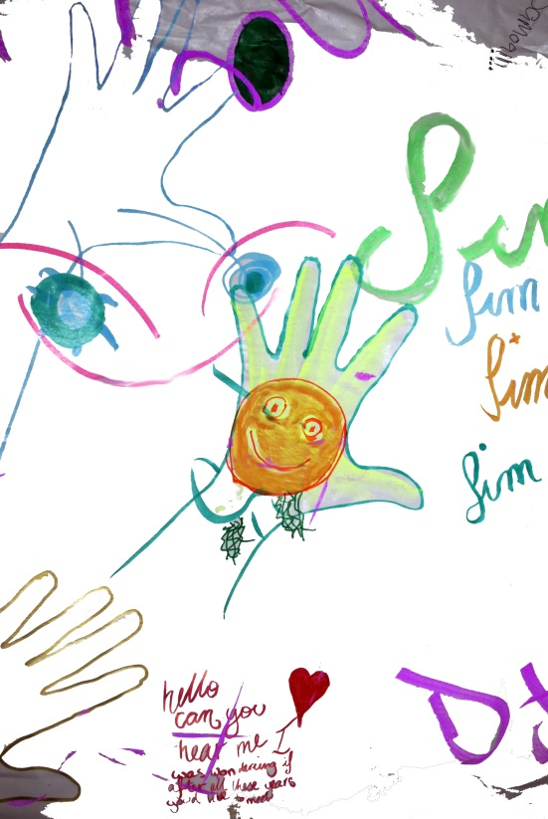

Figure 14. Image from workshop task 7

*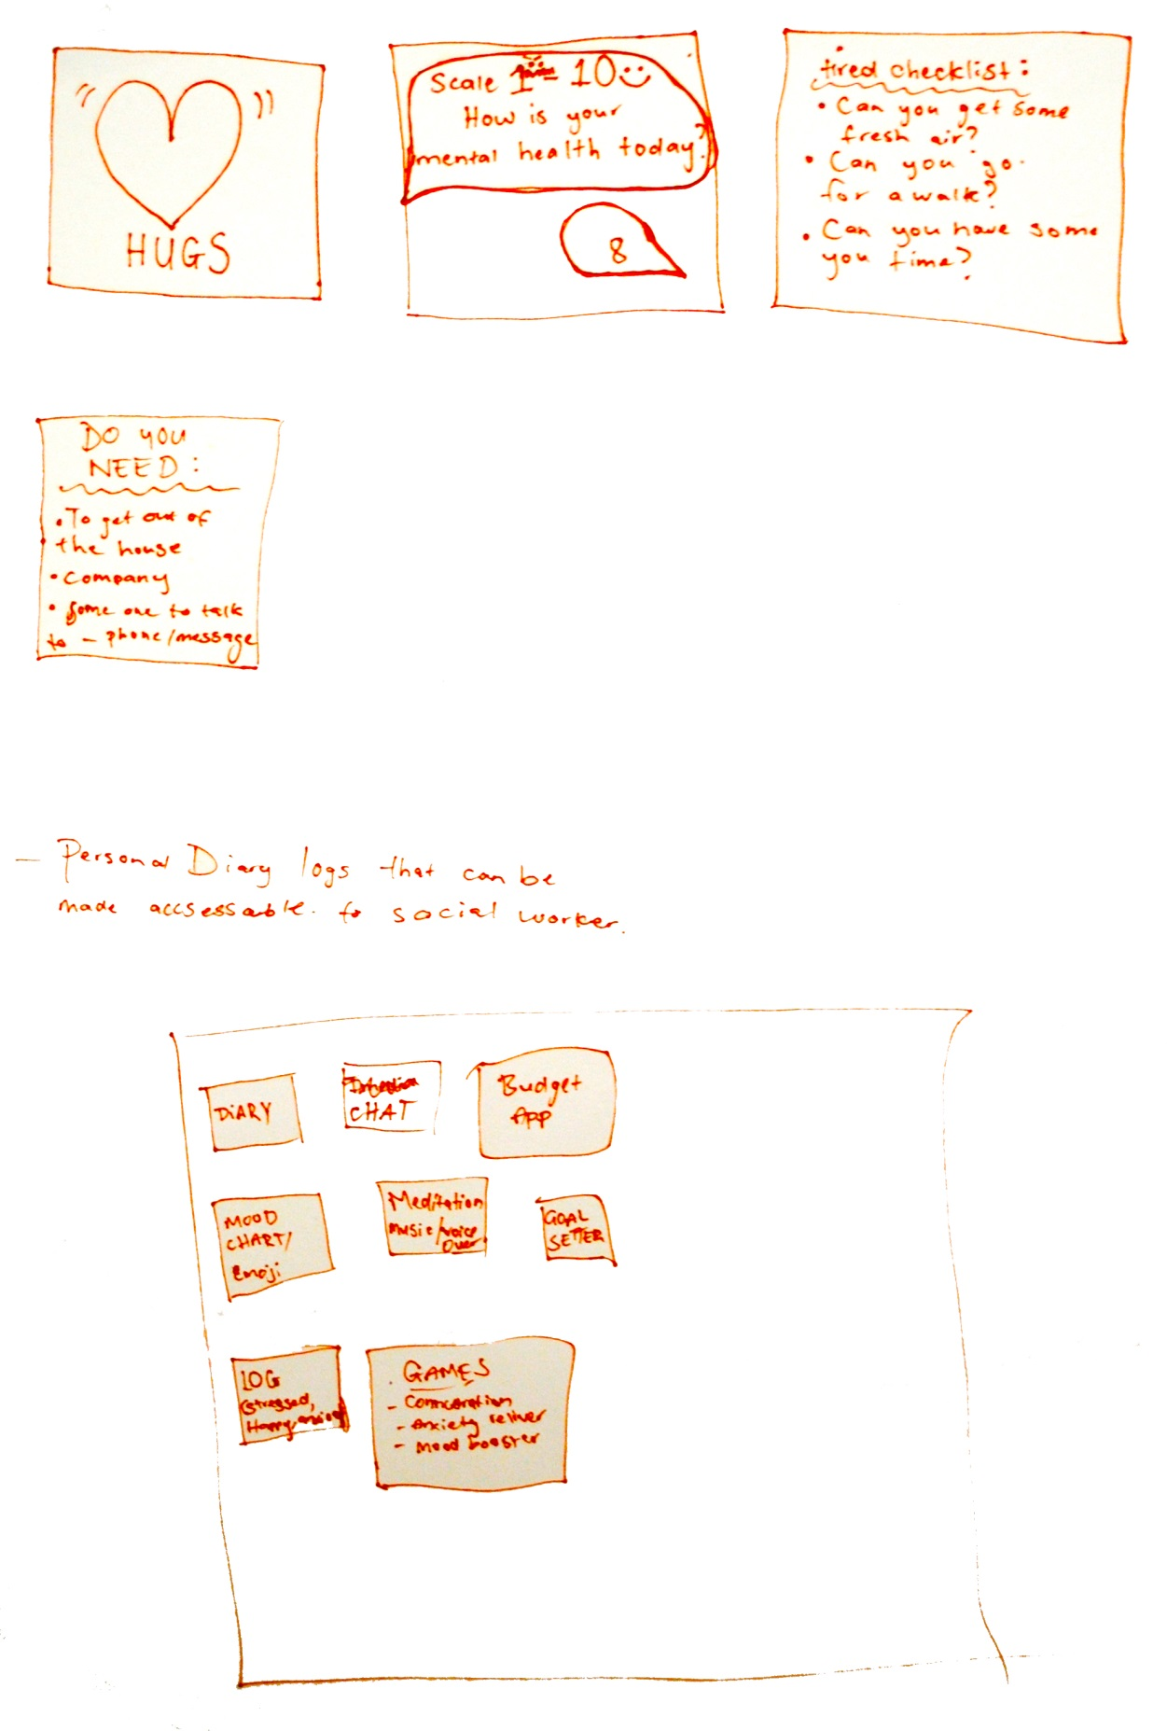*

Figure 15. Image from focus group task 9

Participants in the workshops and focus groups were asked to play/review a number of apps that are currently available and targeted at supporting young people’s wellbeing. Young people identified a number of barriers as well as a number of functionalities within current apps and websites. Issues raised with some of the apps or websites included websites not translating across different devices, long lists to read and/or click through, non-localised support referrals, being unable to zoom in, particularly text pages, no checks to make sure tasks are completed or done correctly and clunky, data heavy, or childish design/functionalities. Barriers discussed included,

“There’s too much words on it. There’s too much reading.”

“…someone telling me something (narrating information) it’s like an audio book”

“that comments are moderated by someone to control for negative or bad behaviour”

The functionalities or activities young people would like to see included in an app to support their wellbeing were,

“…where you set a goal and you have to like have someone hold you accountable for it.”

“I really liked the umm, how the other one had like the diary everyday and the bad and good habits. Like tracking your ...stuff with information”

“Well I like just say for example, you talk about umm something with your health or you know, budgeting, or you were logging it on a program you could maybe share it with them and show them how you are going.”

“Yeah, I was thinking like if there is going to be a basically, like if there is going to be information you can access that you could change your mood as well.”

“Having chat rooms and forums to connect with others.”

“music”

“A forum to discuss elements of everyday things with others.”

“Just to be able to let my worker know what’s happening. Often forget where I have been what’s been happening, just to have connection.”

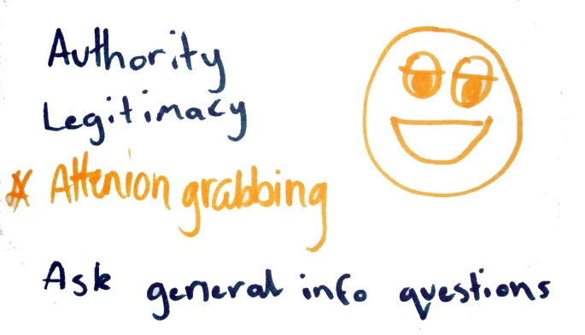

Figure 16. Illustration from Focus Group task 9

“I think something important is that it needs to look professional at first. So even if you’ve got it intuitive and creative so that it stands out, they still want to see something that authorises, or something ligate cause otherwise they are going to look at it and just think it will look like a joke. Or I am not going to wanta continue.”

## 

## Co-design

Three questions guided interpretation of the elements of co-design which would be important to include in future development processes. These were

1. What sort of control do young people want to have in the design, development and implementation of well-being service models which integrate digital technologies aimed at supporting young people’s wellbeing?
2. What key commitments and practices (ways of thinking and responding) are needed to enable processes of mutual discovery, learning, and design in the development of wellbeing digital technologies?
3. How can co-design be orgranised to enable more granular, nuanced and ongoing forms of innovative technologies that support young people and their relationships with service providers?

### What sort of control do young people want to have in the design, development and implementation of well-being service models which integrate digital technologies aimed at supporting young people’s wellbeing?

A standout feature of the participatory approach in the workshops and focus groups was young people’s engagement with a simple emoji app. A cut-n-paste app that offered opportunity for individuals to creatively conceptualise their identity and their sentiments. Figures 1, 4, and 17 below, highlight the diversity and range of how participant represented their emotions, and attitudes.

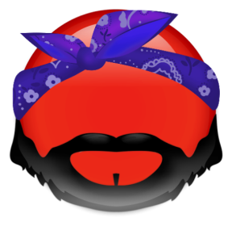  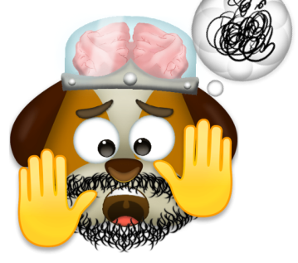

Figure 17. Personal emojis from workshops and focus groups

One participant narrated his emoji as,

“So I have an angry panda. Umm I was programming earlier today and I couldn’t get it working so I ended up yelling at my computer. Which is really just yelling at myself because I couldn’t get it to work.”

Making the emojis presented an opportunity to create visual content as experts of their own lived experiences and to share these on other social media platforms. This was relational to identity construction and underlies the increasing importance of visual elements and intertextual content for young people’s control in digital presentation and solicitation. The emoji creation activity illustrated the significance of young people being in control of self- expression through simple engaging, creative and interactive platforms. A participant justified the pleasurable aspects simply saying,

“We want fun stuff”

### What key commitments and practices (ways of thinking and responding) are needed to enable processes of mutual discovery, learning, and design in the development of wellbeing digital technologies?

The type of practices desirable to authorise mutual discovery, learning, and design with young people are dependent of the demographics and context of the cohorts involved. Across the three methods of data collection it was evident that there were more than three profiles or ‘groupings’ of participants. While, Kasey (p.30) profiled the typical characteristics of participants, that is Anglo Australian female, other participant characteristics also influence ways of thinking and responding to co-design approaches and the final outcome or digital service model required (e.g. differing gender alliances, young people who identified as Indigenous, Pacifica, Indian, or other cultural contexts; young people living outside of metro or regional communities; and young people with disabilities). Nevertheless, Kasey’s representativeness of the typical participant in this consultation suggests that young women aged 14 to 17 years will be the key target group for the development of wellbeing digital technologies.

In relation to the key target group and evident across the data was that young women are knowledgeable about the world of digital technologies as users, are highly social in their use of digital technologies using websites and apps, and have integrated digital technologies as part of their everyday wellbeing. As such co-design approaches should support digital skills development applicable for young women, and enable avenues for active knowledge creation, integration, engineering, validation and evaluation in the development of digital wellbeing tools and apps. Kasey, emphasises an obligatory commitment to engage young women (14 to 17 years) in future co-design practices.

The lessons learnt through this consultation associated with Dana’s profile (p.32) and participatory approaches also, serve as a guide to future commitment and practices of co-design in developing innovative technology solutions to promote youth wellbeing. It was evident as we engaged with participants in the workshops that a structured activity based program (creative or otherwise) was not suitable to facilitate meaningful participation with young people with significant socio-health issues such as, homelessness, drug and alcohol use/misuse, low education attainment, and unemployment. In the workshops, participants shared their perspectives more through informal group discussion than in the activities. Although, the activities were an important backdrop through which to initiate discussions. The facilitator observed,

“Participants had difficulty exploring broader elements of wellbeing without heavy prompting from facilitators. Data emerged when having small group and individual discussions, and related strongly to the participant’s individual circumstance and current situation- eg. Where they were sleeping that night or their current health state.”

Hence, commitment to small group (3 to 4) and relational practices would be recommended with this cohort. Participants in the workshops offered very frank and honest discussion of their experiences. Co-design practices will need to facilitate the unique social dynamics of this cohort and bridge communication gaps.

The profile of Luke (p.31), also requires specific consideration in co-design processes. As the typical male user Luke described young male’s interest in gaming, social connectivity and associated perspectives of wellbeing. A number of male participants in the workshops and focus group were perceptive and proficient in their understanding of digital technology design. One participant explained,

“I am the dude that comes up with the ideas. Asks what’s up, develop it, test it, get it out to many people. Just basically what you are doing right now just shoving it all into a game and then pretty much having a team of programmers to help me get it all working.”

In some aspects Luke, as the typical young male participant, exemplified a young male who wants to be engaged but in some ways may overlook, or be overlooked in his wellbeing needs and goals. As suggested by a participant in a focus group,

“Another thing to consider is that because these are very specific and targeted- umm sometimes there is not more general options and some people don’t want to go into that so quickly... [this] seems to be more of a self-help type of thing. I would probably say it was more mental than any like any physical help. Yeah”

Co-design with young men, and also other gender distinct groups will need to respond to varied and different expression and enactment of wellbeing and needs for support using digital technologies.

### How can co-design be organised to enable more granular, nuanced and ongoing forms of innovative technologies that support young people and their relationships with service providers?

Successful co-design processes rely on a great deal of participatory engagement to open up the possibilities and improvements that enhance young people’s relationships with service providers. Co-design at its core, underpins the idea that collaborative, cooperative and community-centred approaches to creating social good will lead to more effective services and, ultimately, greater social impact (Burkett, 2016).

This consultation has emphasised young people’s perspectives towards the desired end of developing innovative technologies to support wellbeing and strengthen the effectiveness of worker-young person support processes. As such, this has ensured young people’s views and voice are embedded in future development of digital service tools. However, *the effectiveness of worker-young person support processes* does signpost a requirement to draw on the perspectives of workers also, as users in the design and delivery of services. Young people and workers could be involved in the creation of a visual, real time record of life experience as a way to capture experiences for discussion and client management and to help contextualise and explore the practices, cultures, and content of effective worker-young person support processes.

Moving forward co-design should not involve, or be considered, just a client engagement activity. In practice young people will require resources, skills and training along with ongoing support to open up the possibilities of participation beyond a predominately consultative approach. Co-design processes should be organised to nuance connections, rapport, self-determination, privacy, safety and will need to facilitate cross-sectorial communication and partnership. These will comprise a focus on policies, programmes, software, digital devices, institutional and community arrangements. Therefore, methodology and principles should be carefully considered to determine the level of co-design desired and achievable, and the scaffolds with which to support young people’s influence, decision-making and integration of expertise, technical and otherwise.

# Conclusion and Learnings

This technical report has consolidated learnings from the YouEngage consultation that aimed to gain young people’s perceptions of what is important to their wellbeing and how using websites and/or apps can promote their wellbeing and strengthen relationships between young people and their workers and/or counsellors. The targeted population included young people who are actual or potential clients of BYS and Kids Helpline. A collaborative, iterative approach enabled the project team and both stakeholders to refine and deliver the project with mutually agreed key questions, methodologies and outcomes. Through the methods of engagement during a twelve-week period, 404 young people contributed to the consultation.

What wellbeing meant to young people, as voiced in this consultation, highlights wellbeing as multi-faceted and deeply in tune to beliefs of wellbeing prevailing as a young person’s core meaning and value as a human being. Typically, participants implied they felt good and that life was going well. Nevertheless, there was indication that they may not necessarily be thriving with life as it stands for them.

Notably, there was an identified gap in particpation by young women and men, particularly in the survey method. The low participation and engagement of young men in health and wellbeing services and research has been discussed by others with a focus on using technology to engage with young men (Ellis, et al. 2014, 2015; Rickwood, 2005). There were no notable gender difference in respondent’s perception of wellbeing, a point has been observed in other studies investigating young people’s understanding of wellbeing (Dex, and Hollingworth, 2012). While, like young women, young men were likely to engage in social media and chat with friends, they are more likely to use websites for gaming and entertainment purposes. Further interpretation of the data in relation to gender based differences is warranted.

As an Anglo Australian female, Kasey’s profile (p.30) summarised the average characteristics across the 404 participants. Nevertheless, evident across the three methods of data collection, there was a rich diversity related to gender identification (transgender, non-binary, gender fluid, queer and demiboy/girl), cultural identification (Aboriginal, American, Argentine, Asian, African nations, Chinese, English, European, Filipino, Indian, Pacifica, Middle Eastern, and by religion) and region (young people responded to the survey from across Australia, but mostly from metro and regional communities, young people who participated in the workshops and focus groups were from the greater Brisbane area). Predominately, respondents access the internet everyday using a range of platforms, and often on smartphones. The results suggest that young women are highly social in their use of digital technologies and use devices actively to support their wellbeing goals and needs, but not always conjunction with wellbeing agencies or services. Notably, from Kasey’s profile is that generally young women are reasonably happy with their life, but would like some elements to be different.

The results offer learnings and insight into young people’s perspectives of wellbeing. For example, health, happiness and physical and mental conditions were key qualities that young people related to wellbeing. Importantly young people’s perception of wellbeing was highlighted as, a state, a right, an attitude and self-determined. This perception provides valuable insights into the ways in which young people prioritise their wellbeing, goals, requirements and needs, and in which they recognise that wellbeing is interconnected to *“looking after yourself*”and *“to other people to help you grow your wellbeing”*. Wellbeing is balanced between the personal and the social and as such the benefits of wellbeing might be considered a process of accrual dependent upon physical, psychological and social experiences to inform the future direction of a young person’s wellbeing (Gillet-Swann and Sargeant, 2015).

The learnings about young people’s perspective of wellbeing show young people grappling with the routes and relative qualities for everyday wellbeing. Their understandings and enactments of wellbeing were perceived to transpire in ways that can be contradictory and problematic for service provider’s understanding of wellbeing services. For example, the relevance of being happy as a characteristic of wellbeing was observed to occur in direct contradiction to health as a characteristic of wellbeing for young people in some situations, and particularly in strategies used by young people to counter emotions and difficulties emergent in crisis situations. Well-being service delivery, strategies or interventions should encompass practices that encourage young people’s capacity for agency, self-care, support networks, and joint responsibility in ways which meet individual, interdependent and system based needs of young people. Evident across the data was young people’s need to maintain control in their interactions to seek help for their problems and in their perspective of wellbeing as self-determined. Evans and Prilleltensky (2007) recommend that agencies need to support young people to build their own self-determined capabilities while also, creating opportunities to work alongside workers to address injustices.

The consultation engaged conversation with young people about their relationships with workers and has commenced a process to better understand how and why innovative technologies might be used to support wellbeing and strengthen the effectiveness of worker-young person support processes. The data only sketchily, determines what an innovative technology solution to promote youth wellbeing might look like and be.

A key learning emergent from the data suggests that a service model that integrates digital technologies or tools to support young people’s wellbeing goals must build on personal contact with workers or counsellors to help young people achieve their wellbeing goals. Young people uphold the value of the relationship with their worker above other beneficial ingredients or tasks. Young people particularly value mutuality, trust and a sense of friendship with their workers or counsellors (Gibson et al., 2016). Not surprisingly, many participants in this consultation agreed that it was true that it is important to speak with the same person each time, This is true of both face-to-face contact and contact through digital technologies. Trust was indicated as an important feature for engagement with services to support wellbeing. Trust, familiarity and rapport are themes highlighted in other literature as a precondition for young people to discuss sensitive issues, are associated with feeling safe, and develops in the context of a sustained relationship (Ambresin et al., 2013; Rickwood, Deane, Wilson and Ciarrochi, 2005; Trevithick, 2003). Evidenced in the data, young people expected that digital tools would provide a continuance between face-to-face sessions with workers around young people’s needs. Young people indicated that in crisis they would want to contact workers directly by phone.

For participants who more typically aligned with the target population of highly disadvantaged and vulnerable young people, the significance of developing a meaningful relationship in support of their wellbeing was observed as someone that could provide advice, help them navigate services for accommodation, health and other wellbeing right, advocate and help them to have faith and hope. It could be argued that worker and agency support is of utmost important when there is little or no parental involvement in the young person’s life and in which they do not have the social capital scaffolding (intimacy and belonging) associated with family. This is an area that has received little attention in the literature on young people’s wellbeing and predominantly with an emphasis on educational support (Lee, et al., 2016).

Being transient or homeless directly impacted young people’s capacity to access resources and conditions that support their wellbeing as a human right. How might structural arrangement to enhance these rights based conditions be supported through a model of service delivery and digital technologies? Conceivably, a focus on inter-sectoral collaboration that addresses inequalities and improve access to these resources is required. Digital strategies supported through inter-sectoral networks could potentially cross boundaries to enhance protective factors, increase access to resources, increase knowledge, support service advocacy, and provide practical ways for young people to exercise control, expression, and choice for their wellbeing. This may require agencies and services to think differently about how they can share and expand resources and opening up new opportunities to engage with young people across varied sites. Further, attention to intentionally integrate inter-sectoral collaboration is necessary to challenge traditional boundaries of service delivery and increase the potential of services and young people’s networking, knowledge production, conversations, and innovative expression.

A key learning to consider in moving forward in the development of digital tools to promote wellbeing and strengthen relationships between young people and their workers and /or counsellors is that engagement through technology must primarily be built on personal interactions. Opportunities must be available for young people to engage and make connections across networks (services, workers and peers), facilities and resources and that allow self-expression to flourish. The integration of digital tools should be simple, engaging, creative and through interactive platforms that are both online and offline.

The consolidated learnings from the data, documented in this report, should be used to support ongoing engagement of young people in a variety of ways, phases, and stages for future development of digital tools. The *effectiveness of worker-young person support processes* also suggests that workers, as key stakeholders in the development need to be consulted. We suggest that there is an opportunity for participatory engagement of a core group of young people to critically explore and examine current communication tools and interactions with workers and ‘the socio-technical assemblages that are complex and performative’ in interactions (Collin, and Swist, 2016 p.306). Young people will require strong supports, skills development, shared language, social engagement resources and authority to challenge and respond to emerging or new ‘problems’ to be addressed through a user-centric approach (Hagen, et al., 2012). Fostering co-design processes should track the outcomes and impacts of involving young people in the design and delivery of digital services. Despite the potential of involving young people in technology-based service co-design there is a gap in research that identifies the impacts and outcomes of participatory approaches for service delivery and for the participants (Burkett, 2016; Orlowski, et al., 2015).

## Onwards

The lessons learnt through this consultation will be important to consider for the future development of innovative digital services to promote young people’s wellbeing. The consultation involved a multi-pronged approach to provide first-hand insights of young people’s expectations, experiences and needs for innovative technology solutions. The perspectives presented in this report can serve as a guide to the development of digital strategies and for future commitment and practices of co-design. Additionally, this report serves as a guide to facilitate secondary data analyses in the creation of future digital wellbeing tools. A number of considerations for onward progress are highlighted below,

* Young people’s wellbeing is multi-faceted and deeply in tune to beliefs of wellbeing prevailing as a young person’s core meaning and value as a human being.
* Young people need and want personal contact and practical support to help them achieve their wellbeing goals.
* Cost free and stigma free services are highly important in young people’s choice and access of digital services.
* Young people want to be in control of their connections and relationships to support their wellbeing through digital technologies.
* The young women, and indeed all the participants across the methods are knowledgeable about the world of digital technologies as users, are social in their use of digital technologies, are using websites and apps, and have integrated digital technologies as part of their everyday wellbeing.
* To resonate with young people’s multi-faceted understanding of wellbeing, digital interventions should include opportunities to engage and make connections across networks (services, workers and peers), facilities and resources.
* Varied levels of privacy will be an important consideration for the development of digital tools and the integration of client-management systems.
* Digital services should extend health and emotional frameworks to also attend to the importance of self-determination and human rights for ‘being well’. Practices that encourage young people’s capacity for agency, support, knowledge and responsibility in ways which meet individual, interdependent and system based needs of young people are recommended.

# References

Ambresin, A.-E., Bennett, K., Patton, G. C., Sanci, L. A., & Sawyer, S. M. (2013). Assessment of youth-friendly health care: a systematic review of indicators drawn from young people's perspectives. *Journal of Adolescent Health, 52*(6), 670-681.

Australian Association of Social Workers. (2010). *AASW: Code of Ethics*. Canberra: Australian Association of Social Workers. www.aasw.asn.au

Burkett, I. (2016). *Co-design for Social Good*. Paper presented at the Design 4 Social Innovation Rethinking Ageing, Sydney.

<http://www.design4socialinnovation.com.au/news/co-design-social-good-ingrid-burkett/>

Burns, J., Davenport, T., Christensen, H., Luscombe, G., Mendoza, J., Bresnan, A., . . . Hickie, I. (2013). *Game on: Exploring the impact of technologies on young men’s mental health and wellbeing*. *Findings from the first young and well national survey.* Melbourne: Young and Well Cooperative Research Centre.

Collin, P., & Swist, T. (2016). From products to publics? The potential of participatory design for research on youth, safety and well-being. *Journal of Youth Studies, 19*(3), 305-318.

Creswell, J. W. (2013). *Research design: Qualitative, quantitative, and mixed methods approaches*. Thousand Oaks: Sage publications.

Denzin, N. K., & Lincoln, Y. S. (2011). *The Sage handbook of qualitative research*: Sage.

Dex, S., & Hollingworth, K. (2012). Children’s and young people’s voices on their wellbeing. *Childhood Well-Being Research Centre, Working Paper, 16*.

Ellis, L. A., McCabe, K., Davenport, T., Burns, J. M., Rahilly, K., Nicholas, M., & Hickie, I. B. (2015). Development and evaluation of an Internet-based program to improve the mental health and wellbeing of young men. *Interactive Technology and Smart Education, 12*(1), 2-13.

Ellis, L. A., McCabe, K. L., Rahilly, K. A., Nicholas, M. A., Davenport, T. A., Burns, J. M., & Hickie, I. B. (2014). Encouraging young men's participation in mental health research and treatment: perspectives in our technological age. *Clinical Investigation, 4*(10), 881-888.

Evans, S. D., & Prilleltensky, I. (2007). Youth and democracy: Participation for personal, relational, and collective well‐being. *Journal of community psychology, 35*(6), 681-692.

Firth, J., Torous, J., Nicholas, J., Carney, R., Rosenbaum, S., & Sarris, J. (2017). Can smartphone mental health interventions reduce symptoms of anxiety? A meta-analysis of randomized controlled trials. *Journal of Affective Disorders*. *218*, 15-22. doi:https://doi.org/10.1016/j.jad.2017.04.046

Franzosi, R. (Ed.). (2008). Content analysis. London: SAGE.

Gibson, K., Cartwright, C., Kerrisk, K., Campbell, J., & Seymour, F. (2016). What Young People Want: A Qualitative Study of Adolescents’ Priorities for Engagement Across Psychological Services. *Journal of Child and Family Studies, 25*(4), 1057-1065.

Gillett-Swan, Jenna K. & Sargeant, Jonathon (2015). Wellbeing as a process of accrual : beyond subjectivity and beyond the moment. *Social Indicators Research*, *121*(1), pp. 135-148.

Gwinner K. (2016). Arts, therapy, and health: Three stakeholder viewpoints related to

young people’s mental health and wellbeing in Australia. *The Arts in Psychotherapy. 50* 9–16

Guest, G., McQueen, K., & Namey, E. (2012). *Applied thematic analysis*. Thousand Oaks, CA: SAGE.

Guillen-Royo, M. (2010). Realising the ‘wellbeing dividend’: An exploratory study using the Human Scale Development approach. *Ecological Economics, 70*(2), 384-393.

Hagen, P., Collin, P., Metcalf, A., Nicholas, M., Rahilly, K., & Swainston, N. (2012). Participatory Design of evidence-based online youth mental health promotion, intervention and treatment.

Krabbenborg, M. A., Boersma, S. N., van der Veld, W. M., Vollebergh, W. A., & Wolf, J. R. (2017). Self-determination in relation to quality of life in homeless young adults: Direct and indirect effects through psychological distress and social support. *The Journal of Positive Psychology, 12*(2), 130-140.

Kurdiji 1.0, (2017) -see *Indigenous Warlpiri elders want to blend traditions into app to help tackle suicide risk. http://www.abc.net.au/news/2017-04-04/reducing-indigenous-suicide-through-tradition-and-technology/8414248*

Lee, S., Chung, J. E., & Park, N. (2016). Network Environments and Well-Being: An Examination of Personal Network Structure, Social Capital, and Perceived Social Support. *Health Communication*, 1-10. doi:10.1080/10410236.2016.1242032

Lippman, L. H., Moore, K. A., & McIntosh, H. (2011). Positive indicators of child well-being: A conceptual framework, measures, and methodological issues. *Applied Research in Quality of Life, 6*(4), 425-449.

Maidment, J. (2006). The quiet remedy: A dialogue on reshaping professional relationships. *Families in Society: the journal of contemporary social services, 87*(1), 115-121.

McLeod, J., & Wright, K. (2016). What does wellbeing do? An approach to defamiliarize keywords in youth studies. *Journal of Youth Studies, 19*(6), 776-792.

Mission Australia, in association with Black Dog Institute (2015). Young People’s Mental Health over the Years: Youth Survey 2014. Sydney: Mission Australia.

Morse, J. M., & Niehaus, L. (2016). *Mixed method design: Principles and procedures*. New York: Routledge.

Naranjo-Bock, C. (2012). Creativity-based Research: The Process of Co-Designing with Users. *UX Magazine*, *4*, 2012.

National Health and Medical Research Council (2014). *Ethical considerations in quality assurance and evaluation activities*. Canberra: National Health and Medical Research Council.

Patton, G. C., Sawyer, S. M., Santelli, J. S., Ross, D. A., Afifi, R., Allen, N. B., . . . Bonell, C. (2016). Our future: a Lancet commission on adolescent health and wellbeing. *The Lancet, 387*(10036), 2423-2478.

Redmond, G., Skattebol, J., & Saunders, P. (2013). *The Australian child wellbeing project: overview*: Australian Child Wellbeing Project.

Rickwood, D., Deane, F. P., Wilson, C. J., & Ciarrochi, J. (2005). Young people’s help-seeking for mental health problems. *Australian e-journal for the Advancement of Mental health, 4*(3), 218-251.

Sarvimäki, A. (2006). Well-being as being well—a Heideggerian look at well-being. *International Journal of Qualitative Studies on Health and Well-being, 1*(1), 4-10. doi:10.1080/17482620500518101

Silverman, D. (2005). *Doing qualitative research* (2nd ed.). London: Sage.

Trevithick, P. (2003). Effective relationship-based practice: a theoretical exploration. *Journal of Social Work Practice, 17*(2), 163-176.

Vogl G., Ratnaike D., Ivancic L., Rowley A. & Chandy V. (2016). One Click Away? Insights into Mental Health Digital Self-help by Young Australians. Sydney: EY and ReachOut.

Wyn, J. (2009a). Youth health and welfare: The cultural politics of education and wellbeing.

Melbourne: Oxford University Press.

Yarosh, S. & Schueller, S. M. (2017) “Happiness Inventories”: Informing Positive Computing

Technologies Through Participatory Design With Children. *Journal of Medial Internet research*; 19(1):e14

# Appendices

## Appendix 1

### Participant Information and Consent





### ../Survey/Pages%20from%20SurveyMonkey_114final.pdf../Survey/Pages%20from%20SurveyMonkey_114final-2.pdf

## Appendix 2

### YouEngage Online Survey Data Summary

**Introduction**

The survey ran from 2nd March to the 31 March 2017.

There was a total of 372 responses. An initial 200 responses was set at the minimum required for the survey, and it was scheduled to remain open for two weeks.

Initially responses were slow due to the web links and social media being delayed in its going live. However, from there were some responses from 2 march to 14 march but these did not exceed more than 5 responses on any day. From 15 to 21 march there was a significant jump in responses correlating with the links going live and access to the survey increasing as a result. Responses remained constant between 24 and 45 per day until 22 March when they dropped off again and from 26 to 31 March there was a steady decline in responses until the survey was closed on 31 march 2017.

A total of 261 respondents used the social media links to access the survey, while 98 used a direct wed link.

**Q 1. Age.**

372 responded to this question

**Q 2. Gender**

There were 371 responses. Of these, 323 identified as female while only 29 identified as male, and 1 identified as queer. A further 17 respondents identified as gender nonspecific and a range of identities where noted.

**Q 3. Postcode**

There were 332 responses. Of these, 297 identified where they lived. Overwhelmingly, respondents lived in metropolitan areas across Australia (76%). 15% lived in regional area, described as large centres, and 9% lived rurally.

**Q 4. Wellbeing is…**

362 respondents responded to this question with a total of 529 responses. Most respondents responded that health was there primary identifier for wellbeing and of these, 81 also noted physical health as well; this mean that almost all respondents who noted physical as a response also included that as a primary health indicator.

Respondents were also asked why they felt wellbeing was important. This was a free text response with 350 individual responses. A word analysis indicates a spread of reasons for importance. Thematic analysis of each response suggests that respondents feel that wellbeing is an important indicator of an individual’s emotional, physical and social prosperity in general.

**Q 5. On average, I use the internet…**

There were 332 responses to this question. Overwhelming, 934% (n=310) of respondents said that they use the internet every day, while 5.7% (n=19) use it a few times a week and 0.9% (n=3) use it once a week). There were 0.0% responses whereby respondents said that they never use the internet.

**Q 6. When I access the internet I most often use**

There were a total of 329 responses to this question. Just over half of all respondents (n=170) said that they most often use a smartphone to access the internet. 14% (n=46) use a lap top, 6.7% (n=22), iPad use was 4.6% (n=15). A total of 20.1% (n=66) said that they uise all of these. 3.0% (n=10) provided ‘other’ respoises. These consisted of tablet or branded smartphone, one person said that they use X-Box.

**Question 7. I use the internet at:**

A total of 332 responses to this question, and respondents answered regarding where they use the internet and how frequently. Respondents use home (n=330), Library (n=329), Friends (n=326), school (n=328) and public hotspots (n=325). This represents a fairly even distribution of how participant access the internet and that they use a range of platforms.

On average, respondents use the internet at home (n=330) and they access it every day (n=-282), with a rating average of 4.78. The next most frequent use occurred at school (n=328), every day (n=179) with a rating average of 3.96. Respondents also aces the internet using friends resources every day (n=44).

Interestingly, 101 said that they would never use the internet in the library, and 100 would rarely use the internet in the library, while 75 never use public hotpots and 107 rarely use public hotspots.

**Q 8. How do respondents browse the internet?**

A text analysis revealed that an additional comments include 22.22% each for school work and research, while there were only 2 responses (5.56%) said that they used it for assistance with their mental health.

|  |  |  |  |  |  |  |
| --- | --- | --- | --- | --- | --- | --- |
| response | **Never** | **Rarely** | **Sometimes** | **Often** | **Everyday** | **Response Count** |
| Play games | 72 (21.82%) | 118 (35.76%) | **95 (28.79%)** | 29 (8.79%) | 16 (4.85%) | 330 |
| Use Apps | 15 (4.66%) | 39 (12.00%) | 68 (21.12%) | 86 (26.71%) | 114 (35.40%) | 322 |
| Use social media (Snapchat, Facebook, Instagram, etc.) | 13 (4.01%) | 5 (1.54%) | 19 (5.86%) | 35 (10.80%) | **252 (77.78%)** | 324 |
| Email | 8 (2.48%) | 32 (9.94%) | 51 (15.84%) | 84 (26.09%) | 147 (45.65%) | 322 |
| Search random stuff | 20 (6.23%) | 39 (12.15%) | 89 (27.73%) | 93 (28.97%) | 80 (24.92%) | 321 |
|  | | | | | | **Question Totals** |
| Other (please specify) | | | | | | 36 |
| *answered question* | | | | | | **331** |
| *skipped question* | | | | | | **41** |

**Q 9. How do participant use apps?**

When using apps, most respondents, 74.3% (n=246) will use them in both online and off line modes where possible. 22.7% (n=75) use them only online while only 3.0% (n=10) will use them only off line. This indicates that respondents will most likely use an app that they can download and use offline or online.

**Q 10. Name some game you like to play.**

Respondents were asked about their favourite games to play. This question was asked in order to provide later analysis on platform usage. This would require a search of the specific platforms used to develop each game, and this can assist in the development of websites or activities to best match the more popular game platforms.

Frequency of the types of games is presented here. This will enable any future researcher to know what the platform type most used in the popular games is ands be able to replicate this.

However, many respondents said that they do not actually play games at all, or not often. These respondents often use the Internet to social media or may engage in gaming at a minimal level. In any event, their responses indicate that games and gaming platforms are not of interest to them. A key factor with this response is likely to be gender based, given that 323 residents were female and 29 were male the rest were identified more broadly.

When respondents did provide a game, text analysis revealed that Sims was to most popular identified game (5.41%, n=16), followed closely by Candy Crush (4.73%, n-14). These were followed by Pokémon (2.7%, n=8), Episode (2.36%, n=7), Minecraft and Colour Switch (2.03%, n=6 each). Solitaire, Hay day and Subway had the least responses (1.69%, n=5 each).

**Q 11. I like to play games because…**

There were 315 responses to this question. It is likely that the response rated dropped because many who did not respond already noted that they do not play games in Question 10.

**Q12. The sort of apps I like to use are…**

There were 330 responses to this question. The predominant apps that respondents prefer to use are Entertainment (77%), social media type apps (73.9%) and communication type apps (63.3%).

**Q13. I use apps or websites…**

There were 329 responses to this question. Overwhelmingly, apps are used by respondents in order to obtain information (79.6%) or to remain in touch with social events.

In descending order responses were as follows:

1. When I need to know something79.6% (n=262)
2. Just to see what’s new 55% (n=181)
3. to get help to deal with stuff 52% (n=171)
4. Often for fun with games and stuff 48.3% (n=159)
5. to help a friend 37.7% (n=124)
6. in a crisis 30.7% (n=101)

**Q 14. Name a couple of apps**

There were 317 responses to this question. A significant proportion of respondents use Snapchat, Facebook and Instagram. The primary cluster of app use was Snapchat, Facebook and Instagram used together. Many users also accessed music and messaging apps as well. Entertainment apps included respondents who identified apps such as iBook, and creative apps as well. Only 3 identified educational app use and 54 identified health monitoring as app use.

**Q 15. On a scale of 1-5 (5 being always) I mostly use these apps for?**

There were 329 responses to this question. Scores were averaged from 1 (never) to 5 (always). Results indicate that respondents use apps for a range of reasons but usually for keeping in touch and learning information.

**Q 16. Respondents were asked if they felt that their life was going well on a scale of 1 (strongly disagree) to 5 (strongly agree).**

There were 310 responses to this question. Of these, 44 strongly disagreed, 70 disagreed, 85 were neutral, 76 agreed and 35 strongly agreed.

On average, respondents felt that their life was going well in general with the average score at just under 3.

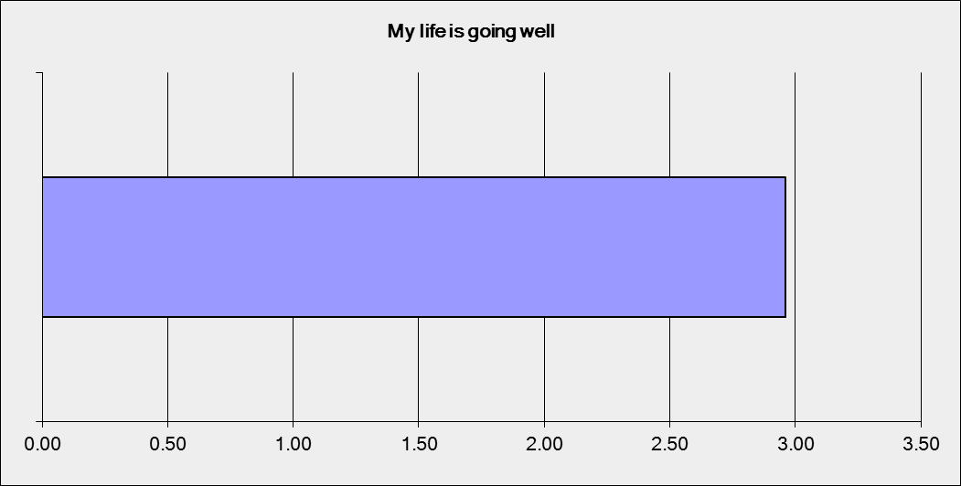

**Q17. Respondents were asked if they felt that their life was ‘just right on a scale of 1 (strongly disagree) to 5 (strongly agree).**

There were 310 responses to this question. Of these, 65 strongly disagreed, 84 disagreed, 80 were neutral, 56 agreed and 25 strongly agreed.

On average, respondents felt that their life was going well in general with the average score at 2.65.

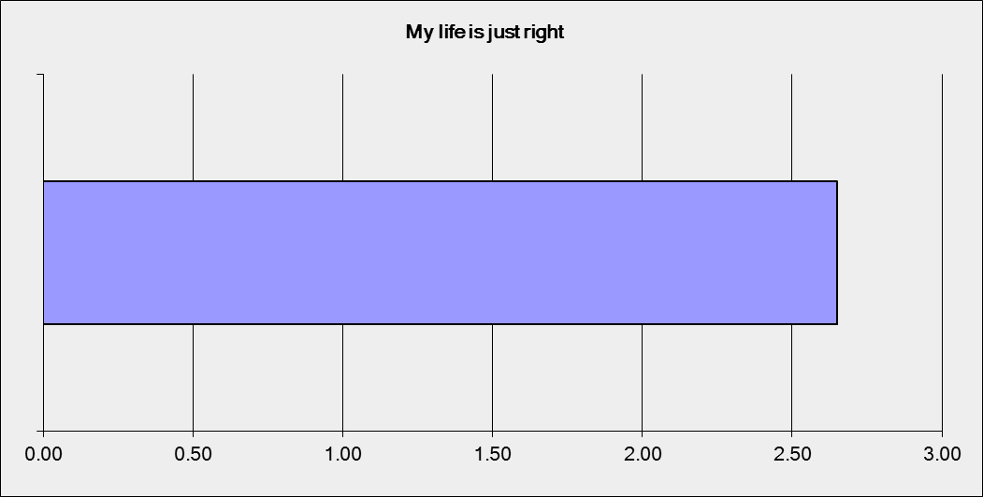

**Q18. Respondents were asked if they wished they had a different life on a scale of 1 (strongly disagree) to 5 (strongly agree).**

There were 310 responses to this question. Of these, 54 strongly disagreed, 60 disagreed, 55 were neutral, 72 agreed and 69 strongly agreed.

On average, respondents felt that their life was going well in general with the average score at 3.14.

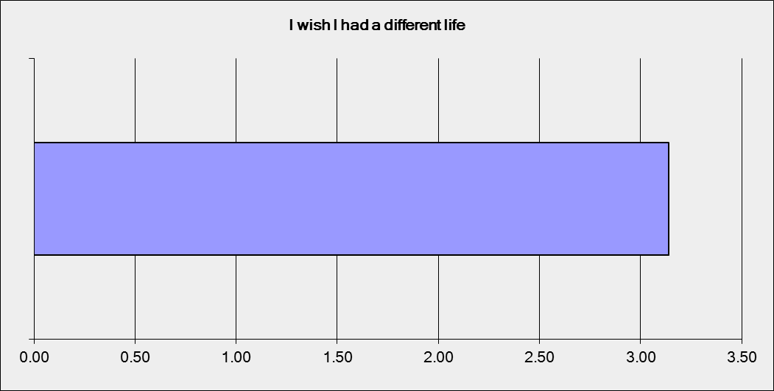

**Q19. Respondents were asked if they felt they had a good life on a scale of 1 (strongly disagree) to 5 (strongly agree).** There were 308 responses to this question. Of these, 11 strongly disagreed, 32 disagreed, 90 were neutral, 94 agreed and 81 strongly agreed.

On average, respondents felt that their life was going well in general with the average score at 3.66.

**Q20. Respondents were asked if they felt they had what they want in life on a scale of 1 (strongly disagree) to 5 (strongly agree).** There were 310 responses to this question. Of these, 47 strongly disagreed, 76 disagreed, 92 were neutral, 68 agreed and 27 strongly agreed

On average, respondents felt that their life was going well in general with the average score at 2.85.

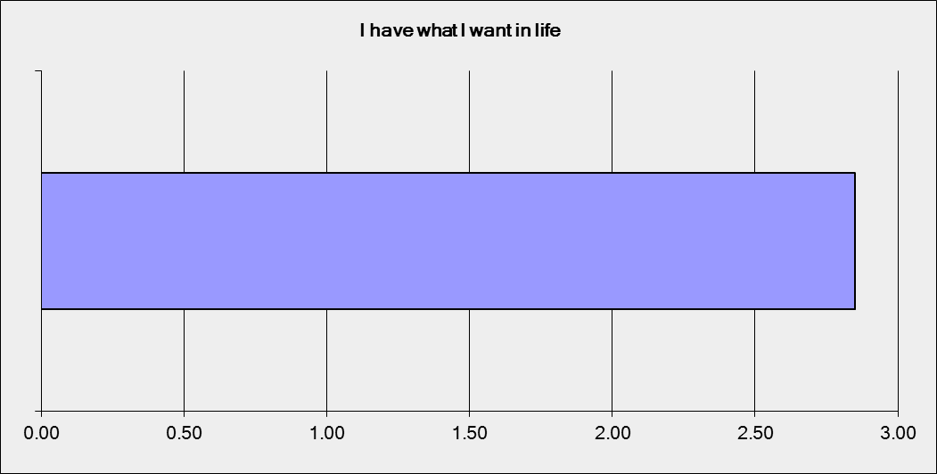

**Q21.** **Respondents were asked if they felt they got the help they need to live the life they want on a scale of 1 (strongly disagree) to 5 (strongly agree).**

There were 309 responses to this question. Of these, 21 strongly disagreed, 65 disagreed, 120 were neutral, 55 agreed and 48 strongly agreed.

On average, respondents felt that their life was going well in general with the average score at 3.14.

**Q22. Respondents were asked what they have need help with in the past 12 months**

There were 307 responses to this question. Much of the assistance that respondents used apps for in the past 12 months was for issues related to their feeling and emotional wellbeing (85.7%), school issues (78.5%) and friends and family issues (77.9%). There were also a significant number of health related issues that advice and assistance was sought for through apps.

**Q23. For help with problem/s, I went to…**

There were 296 responses to this question. This was a free text response question and word response analysis revealed that 32.12% of respondents noted that they used Kids helpline (N=104), and 1.01% uses Brisbane Youth Service. This is most likely based on the platforms of responses in that most were online through Kids Help Line. 11.49% (n=34) said they would come to their psychologist, and 42.57% (n=126) identified ‘friends” as the people to whom they went for help.

**Q24. Respondents were asked if they felt there was a lot of information on the internet to help them solve problems in their life.**

Respondents were asked if this was true of false. 308 respondents responds and 84.7% (n=261) agree that there was a lot of information while 15.3% (n=47) did not agree.

**Q25. Respondents identified the following apps to help deal with problems.**

There were 307 responses to this question. 35.8% (n-110) said that they use both apps and websites to find assistance in dealing with problems. This is reflected throughout the data and respondents also note elsewhere that they would use apps to find quick responses, while they would expect to refer to websites for additional or more detailed information.

|  |  |  |
| --- | --- | --- |
| Apps | 2.9% | 9 |
| Websites | 26.1% | 80 |
| Both | 35.8% | 110 |
| Text/instant messaging | 21.2% | 65 |
| Neither | 8.8% | 27 |
| Other (please specify) | 5.2% | 16 |

**Q26. If you could use an app or website to help deal with problems, what would the thing you most likely use look like?**

There were 308 responses to this question. The figure below indicates that respondents would most likely read information on a website, while they would seek interactive platforms on both websites and apps, with apps being most used for games and general resources.

**Respondents were asked about how they identify their wellbeing in the following questions**

**Q27: being happy**

293 responded and the average rating of being happy as a part of a positive sense of wellbeing was 4.44.

**Q28: My friends**

293 responded and the average rating for friends as a positive part of wellbeing was 4.12.

**Q29. My family.**

292 responded and the average rating for family as a positive part of wellbeing was 4.21.

**Q30. Having a home.**

292 responded. The average rating of having a home as a positive part of wellbeing was 4.49.

**Q31. Getting an education.**

293 responded. The average rating for getting an education as a positive part of wellbeing was 4.39.

**Q32. Having money.**

293 responded. The average rating for having money as a positive part of wellbeing was 3.89.

**Q33. Being valued.**

293 responded. The average rating for being valued as a positive part of wellbeing was 4.31.

**Q34. Being physically able.**

292 responded. The average rating for being physically able was 4.11.

**Q35. My pets.**

293 responded. The average rating for my pets as a positive part of welling was 3.70.

**Q36. How I look.**

293 responded. The average rating for how I look as a positive part of wellbeing was 3.52.

**Q37. Managing what I have to do each day.**

293 responded. The average rating for managing what I have to do each day, as a positive part of wellbeing was 3.94

**Q38. Being treated with respect.**

293 responded. The average rating for being treated with respect as a positive part of wellbeing was 4.38.

**Q39. Spending time doing what I want to do.**

291 responded. The average rating for spending time doing what I want to do as a positive part of wellbeing was 3.94.

**Q40. Being positive about tomorrow.**

293 responded. The average rating for being positive about tomorrow as a positive part of wellbeing was 3.80.

**Q: 41. Being loved.**

293 responded. The average rating for being loved as a positive part of wellbeing was 4.42.

**Q 42. Creatively expressing myself.**

293 responded. The average rating for being able to creatively express myself as a positive part of wellbeing was 3.52.

**Q43. Not being sick.**

293 responded. The average rating for not being sick as a positive part of wellbeing was 3.94.

**Q 44. Things that are connected to my sense of wellbeing**

There were 290 response to this question. Feeling safe and health were the most commonly identified factors contributing to a sense of wellbeing.

**Q 45. Other wellbeing indicators**

There were 133 responses to this question. The primary indicators were friends and family (24.06%), relationships (13.53%) and personal health (10.53%).

**Q46. How do you want your privacy and information managed online?**

There were 276 responses. Overwhelmingly, respondents felt that there information was safe online, and that they would want access to that information. However, this also appear to relate to the respondents being able to talk to a person they feel they know, and who they feel knows them.

**Q47. Preferred ways of seeking help**

There were 275 responses to this question. 64.7% of respondents said that they would use text or other messaging, while 56.4% said that they would use face to face contact. Other data in this survey indicates that respondents would seek assistance form people that they know (Q. 48, 50 and 51), this suggests that the response to texting would be as an initial form of contact in order to establish face to face contact.

**Q 48. How did the respondent last speak to someone?**

There were 272 responses to this question. As noted in question 47 above, the preferred way to contact a person was face to face, or in person (53/7%). 24.6%) indicated text messaging which again suggests that this is for establishing contact or for quickly resolved issues.

**Q 49. I was more able to deal with an issues after seeking support, true or false.**

There were 271 responses to this question. The majority (65.3 %) agreed that they were more able to deal with a problem after speaking to the support person.

**Q 50. Between sessions with a counsellor/youth worker, you might have things to work on or be aware of. What would you find helpful between sessions with your counsellor/youth worker?**

There were 268 responses to this question. Most respondents felt that the ability to contact their counsellor was important (62.7%). This was followed by resources such as tip sheets (52.6%) and progress tracking apps (50.0%).

**Q51. Is it important to speak to the same person?**

There were 272 responses to this question. Overwhelmingly, 85.7% felt it was impotent to speak to the same person each time.

**Q 52. What technology would you use?**

There were 275 responses to this question. The majority will use a smartphone or tablet to access an app. This has implications for what an app will do, and what information this will contain. The second most used technology is the desk top or lap top computer. It appears that respondents will use a computer to access larger and more detailed information, whereas the smartphone of tablet is for quick, app based use.

# Q 53. If I was going to use a really good digital wellbeing app or website I would like it to have …

There were 199 response to this question. Results indicate that respondents will use an app or website for information related to the issues they are currently experiencing. This includes straight content, development and other areas.

**Q 54. Work status**

There were 274 responses to this question. Most were studying fulltime and 25.2% were employed. This reflects the age demographic.

**Q 55 Education status**

There were 273 response to this question. 33.3% had completed year 10 and 35.5% noted their response as ‘other’.